

Technical Visit to Central Wanchai Bypass – Central Interchange and Commissioning Contracts

Date: 27 August 2016 (Saturday)

Time: 9:00 am to 12:00 pm (approximately)

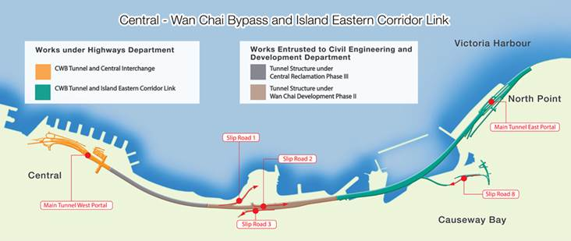

Transportation & Meeting Point: Attendees should make their own arrangements to travel to the site meeting point near Ferry Pier Number 2 by MTR to Hong Kong or Central Station or by Ferry to Central ferry piers. A map will be provided for the short walk between the MTR station and the site office (via the elevated walkway). Attendees should arrive at the site office by 9:00 am for a safety induction and project briefing.

PROGRAMME HIGHLIGHTS
Located at the busiest part of Hong Kong, CWB serves as a strategic route through the north-shore of Hong Kong Island for relieving traffic congestion along the existing Gloucester Road-Connaught Road Central Corridor. The entire route consists of a 4.5 km dual 3-lane trunk road with a 3.7 km tunnel section (see map).

Central Wan Chai Bypass – Tunnel Building, Systems, Fittings & Associated Works (HY/2011/08), the final contract of CWB Project, enables the commissioning of the strategic traffic route. The contract encompasses building, civil and M&E works, including the construction and fitting out of ventilation and administration buildings as well as the route-wide M&E and traffic control and surveillance system. Of particular highlight is the air purification system and thermal barrier fire protection for the tunnel which are the first adopted for traffic tunnels in Hong Kong. For this reason, the visit would be especially interesting for Electrical, Mechanical and Traffic engineers; whilst the tunnel and elevated roadway will interest Civil engineers.

REGISTRATION and ENQUIRY

The number of participants is limited to 40 so get in quick!! Applicants will be accepted on a first-come-first served basis. EAHK's decision shall be final. For registration, please complete and return the reply slip to Simon Fan, preferably by e-mail, Mr. Simon Fan may be contacted on 9351 4963. Please note that the Personal Protective Equipment (at a minimum safety boots) is a requirement for the visit. Anyone unable to bring full PPE, please advise on the reply slip.

CPD

Participation in this event will carry with it the entitlement to claim 3 hours for ongoing CPD requirements.
CPD certificates will be provided.

Reply Slip

To : Engineers Australia, Hong Kong Chapter - Mr. Simon Fan
Email : info@ieausthk.org
Fax : 2430 9080

I wish to register for the following event organized by the Engineers Australia, Hong Kong Chapter
Event : Technical Visit to Central Wanchai Bypass – Central Interchange and Commissioning Contract
Date : 27 August 2016 (Saturday) at 9:00 am to 12:00 noon

From the participant

Last Name (Mr/Ms/Ir/Prof/Dr): ____________________ First Name: ________________________________
Membership No: ____________________ I will bring full PPE – YES / NO (please select)
Car Registration Number: ____________________ (if you wish to request on-site parking)
Tel (Mobile Phone): _________________________ Email: _________________________________________

Important Notice

- The Organizer(s) or the parties concerned would not accept any liability in connection with this function. All participants should be responsible for their own safety and belongings. The organizer(s) shall not be held responsible for any losses or accidents caused to participants arising wholly or partly from their own fault, negligence or physical unfitness.
- The above schedule is subject to change without notice.
- Successful applicants will be notified prior to the event.

