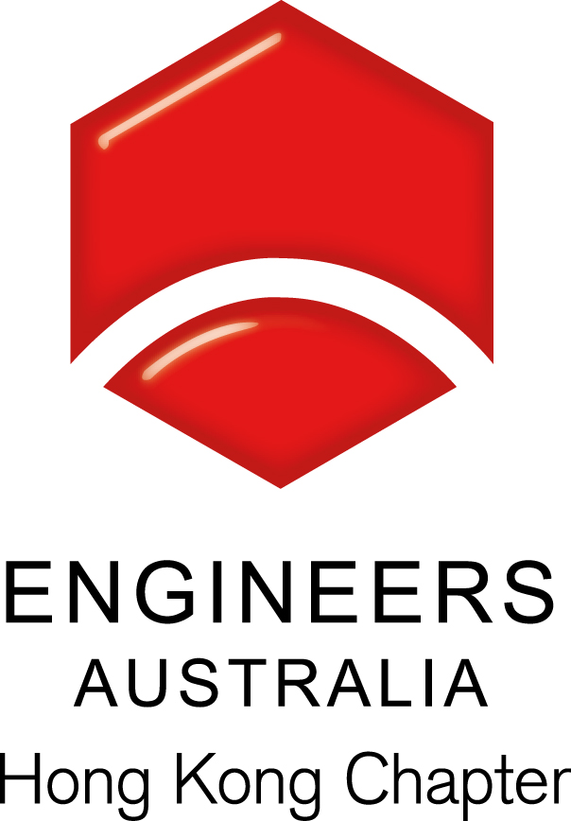
Technical Seminar: Building Sustainability, Solutions for Climate Change
Date, Time & Venue
10 May 2016 (Tuesday): 6:30pm (Networking), 7:00pm (Start of Seminar)
Arup Meeting Room T6A/B, Level 6, Festival Walk, 80 Tat Chee Avenue, Kowloon Tong. Attendees are required to register at the Level 5 Reception.

Programme Highlights
While climate change has been the urgent focus for the world today, contributions of carbon emission from Asian countries has not been discussed enough in the past to allow the professionals to understand the global challenge ahead due to the unprecedented rapid urbanization in the region. As worldwide and Asia’s carbon emissions have reached another record high, it is more urgent than ever to formulate and execute plans for carbon reduction. The possible solutions for the complicated climate change problem have seldom been addressed in a holistic way.

In this Seminar, Dr. Tong will provide ideas for how professionals can work together to resolve the problems associated with climate change, by building better buildings in cities. The speaker has practical experience in taking a Total Building Sustainability approach, and integrating multi-dimensional aspects to achieve economical and sustainability goals. This approach incorporates the industry’s best practices, passive design means, active systems and renewable energies.

Speaker: Ir. Dr. Jimmy TONG
Dr. Jimmy Tong is East Asia Energy Skill Leader and an Associate at Arup focusing on Building Sustainability. An industrial leader in the energy business, Dr. Tong has applied his expertise in energy systems in various sectors, including wind and renewable energy, infrastructure and building services, and product and system development in the manufacturing of electronics, ventilation equipment, and filtration equipment for more than 16 years. Dr. Tong’s current focus is creating and transforming buildings toward a greener future. He obtained a Ph.D. specializing in computational fluid flow and heat transfer from the University of Minnesota.

He is also a guest lecturer at several universities in Hong Kong on the subject of energy and sustainability and co-authored book publication and book chapters and publications in archival, refereed journals. He also serves as a mentor and advisor for the American Society of Mechanical Engineers (ASME), for engineering programs at several universities in Hong Kong and for Friends of the Earth (HK).

Continuing Professional Development (CPD)
Members of Engineers Australia or Support Australia Group (SAG), who attend the Seminar will be issued with a certificate acknowledging 1.5 hours of CPD free of charge.
A cost of HK$ 50 will be required for attendees requiring a CPD Certificate who are neither members of Engineers Australia nor members of organisations affiliated with SAG.
Please indicate in advance by ticking the requirement box in the Registration Form below.

Remarks, Registration & Enquiries
If typhoon signal no. 3 (or above) or the rainstorm warning (red or black) is hoisted or announced to be hoisted in effect within two hours prior to the start of the Seminar, the Seminar will be cancelled without further notice.
The Seminar is free of charge and all participants must be responsible for their own safety and belongings Please complete and return this form to Simon FAN by email: info@ieausthk.org or FAX: 2430 9080 before 9 May 2016. For enquiry, please contact Simon FAN on 9351 4963 or by email.

Engineers Australia Hong Kong Chapter: Technical Seminar
Registration Form – (10 May 2016: 6:30pm to 8:30pm)
Registration Form
To: Simon FAN
From:
Name in Full |  | * Guest / EA No. / SAG No. (* - Please delete, as appropriate)
Mobile No. |  | Email
□ I require a CPD Certificate and am currently a fully paid member of Engineers Australia/SAG
□ I require a CPD Certificate and agree to pay HK$ 50

