
Technical Site Visit to Zero Carbon Building (ZCB)

Date: 7 May 2016 (Saturday)
Time: 10:15 am to 1:15 pm
Gathering Point: At MegaBox Shuttle Service Stop (near taxi stand), Exit A of Kowloon Bay MTR Station
(please refer to the map in the Registration Form)
Site Visit Highlights

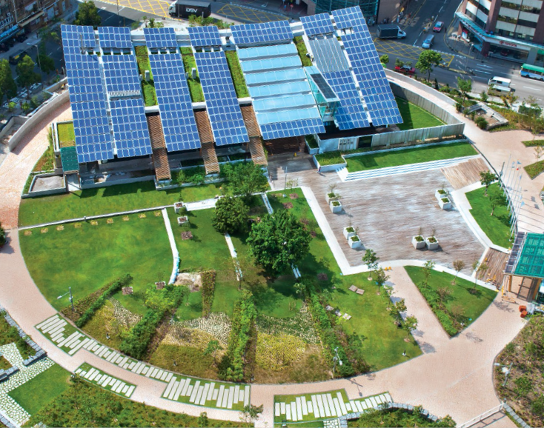
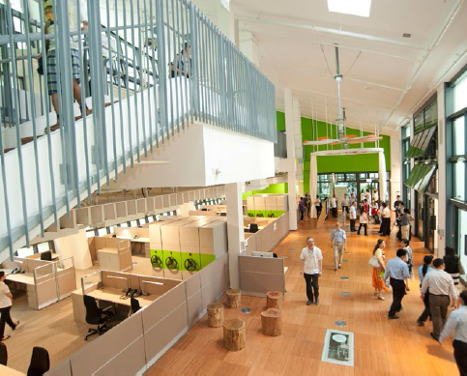

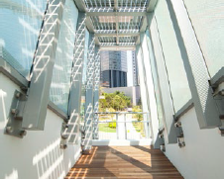

Designed as an exemplar project for aggressive carbon emission reduction initiatives, the centre is one of the most comprehensive zero carbon buildings in the world. To reduce energy consumption by 45%, the building design utilises natural ventilation, day lighting, sustainable materials and an integrated landscape that minimises the urban heat island effect. In addition, ultra-energy-efficient building systems with smart control monitors minimised consumption. The residual energy is met through on-site renewable energy generation, a combination of photovoltaic and biodiesel trigeneration, with the excess exported to the grid to cover the construction and embodied energy of the building.

The project is an attempt to create a new kind of environment that integrates work, education and social well-being. The three storey building comprises an exhibition/education centre, an eco-home show flat, an eco-cafe and a multi-function room; and the open space will be the first native urban woodland in Hong Kong.

While there are many zero carbon buildings in relatively cool or mild climates (typically designed to be tightly sealed spaces with little energy exchange with the exterior), there are relatively few examples in the hot and humid sub-tropical climate such as in place like Hong Kong. ZCB is a building that has the flexibility to switch between a tightly sealed air-conditioned environment to a highly porous cross-ventilated mode with low thermal inertia.
The building goes beyond the traditional definition of zero carbon. It is connected to the local grid and produces on-site renewable energy, from a combination of photovoltaic panels and a biodiesel tri-generation system, to offset the power consumed on an annual basis. The excess is exported to the local grid to cover the embodied energy of its construction process and building materials.

The ZCB is also a smart building with more than 3,000 sensors reporting on every aspect of its performance. The results are displayed interactively on a 3-D model of the building in real-time. This includes four microclimate monitoring stations placed around the site to enhance our understanding of how the building
performs and interacts with its surroundings.

In this site visit we will go through the overview of the Zero Carbon Building project as well as view the facilities and back of house of Zero Carbon Building. 3 CPD hours Certificate will be awarded to attendees.

The address of ZCB is 8 Sheung Yuet Road, Kowloon Bay, Kowloon.

Itinerary

Time | Activity
10:15 | - Meet at Gathering Point
10:30 – 10:45 | - Make our way to ZCB (by MegaBox shuttle service)
10:45 – 11:00 | - Welcome Speech and Briefing
11:00 – 12:15 | - Tour of ZCB and Back of House
12:15 – 12:45 | - Q&A and discussion session
12:45 – 1:15 | - Free time to explore ZCB
1:15 | - End of Visit (attendees can choose to take the MegaBox shuttle service back to Kowloon Bay MTR or feel free to explore the surrounding area themselves)

Admission Charge
ZCB Admission cost is HK$20 each and to be paid by the attendee (please prepare exact change).

Continuing Professional Development (CPD)
Members of Engineers Australia and Support Australia Group (SAG), who attending the visit will be issued with a certificate acknowledging 3 hours of CPD free of charge.
A cost of HK$ 50 will be required for Non Engineers Australia members who require a CPD Certificate. Please indicate in advance by ticking the requirement box in the Registration Form below.

Notice for Registration

- The number of participants is limited to 30, and priority will be given to EAHK members.
- All participants should be responsible for their own safety and belongings and need to sign an Undertaking upon registration.
- If typhoon signal no. 3 (or above) or the rainstorm warning (red or black) is hoisted or announced to be hoisted in effect within two hours prior to the start of the Site Visit, the Site Visit will be cancelled without further notice.
- Please complete and return the Registration Form to Simon FAN by email: info@ieausthk.org or FAX: 2430 9080 before 3 May 2016.
- Successfull applicants will only be confirmed by Simon FAN (phone : 9351 4963)

Engineers Australia Hong Kong Chapter:
Technical Site Visit to “Zero Carbon Building”
(7 May 2016) Registration Form

To: Simon FAN
From:

Name in Full |  | * Guest / EA No. / SAG No. (* - Please delete, as appropriate)
Mobile No. |  | Email

□ I require a CPD Certificate and am currently a fully paid member of Engineers Australia/SAG
□ I require a CPD Certificate and agree to pay HK$ 50

Form of Undertaking
I fully understand and willingly accept that any invitation or permission gives to me to the tour shall be subject to but not exclusive to the following conditions:-
- Engineers Australia, Hong Kong Chapter (EAHK) and/or the organizer(s) shall owe no common duty of care to any visitor in respect of risks or dangers arising from the state of the facilities, or execution of any work or the carrying out of any activities therein.
- EAHK and/or the organizer(s) shall be absolved from all liabilities arising out of any incident or accidents causing loss, damage or personal injury (whether fatal or otherwise) howsoever caused to the visitor and whether the same is caused by negligence or not.
I am also fully aware that the signing of this Form of Undertaking by me shall indicate my acceptance of any risk or danger encountered due to the visit dated 7 May 2016.

Signature: _________________________

Full Name: _________________________

MegaBox shuttle service from Kowloon Bay MTR Exit A
