
Technical Site Visit to Tuen Mun – Chek Lap Kok Link (TM-CLKL)
Northern Connection: Contract No. HY/2012/08

Date: 16 April 2016 (Sat)
Time: 9:15 am to 12:15 pm
Gathering Point: Tuen Mun MTR Station, Public Transport Interchange at G/F V-City
Refer attached pics
Briefing Session: AECOM Site Office of Contract No. HY/2012/08
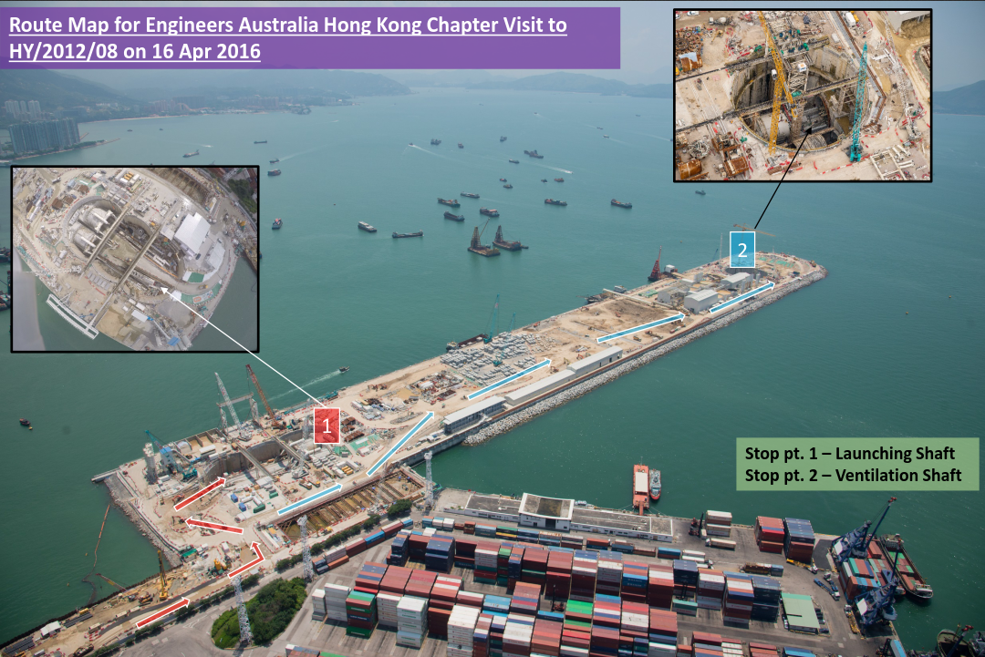
Site visit highlights:

- Overview of the Tuen Mun – Chek Lap Kok Link Northern Connection project
- View the current works progress

Proposed itinerary:

Time | Activity
9:15 | - Pick up by site coach to site office
9:30 – 9:35 | - Welcome address
9:35 – 10:00 | - Briefing of the TM-CLKL Northern Connection
10:00 – 10:05 | - Q&A
10:05 – 10:10 | - Safety briefing and group photo-taking
10:10 – 12:00 | - Site visit
12:00 – 12:15 | - Travel by site coach from site office and drop off at gathering point
12:15 | - End of visit

Notice for Registration

- Participants are expected to bring their own PPE (hard hat with chin strap, reflective vests, and safety shoes). Please let us know if you need to borrow any of the above PPE.
- The number of participants is limited to 25, and priority will be given to EAHK members.
- All participants should be responsible for their own safety and belongings and need to sign an Undertaking upon registration.
- If typhoon signal no. 1 (or above) or the rainstorm warning (red or black) is hoisted or announced to be hoisted in effect within two hours prior to the start of the visit, the visit will be cancelled without further notice.
- Please complete and return the Registration Form to Simon FAN by email: info@ieausthk.org or FAX: 2430 9080 before 9 April 2016.
- Successfull applicants will only be confirmed by Simon FAN (phone : 9351 4963)

Engineers Australia Hong Kong Chapter: Technical Visit
“Tuen Mun –Chek Lap Kok Link Northern Connection”
(16 April 2016) Registration Form
To: Simon FAN
From:

Name in full: |  |  | IEAust no.
Mobile : |  |  | Email:

Form of Undertaking
I fully understand and willingly accept that any invitation or permission gives to me to the tour shall be subject to but not exclusive to the following conditions:-

- Engineers Australia, Hong Kong Chapter (EAHK) and/or the organizer(s) shall owe no common duty of care to any visitor in respect of risks or dangers arising from the state of the facilities, or execution of any work or the carrying out of any activities therein.

- EAHK and/or the organizer(s) shall be absolved from all liabilities arising out of any incident or accidents causing loss, damage or personal injury (whether fatal or otherwise) howsoever caused to the visitor and whether the same is caused by negligence or not.

I am also fully aware that the signing of this Form of Undertaking by me shall indicate my acceptance of any risk or danger encountered due to the visit dated 16 April 2016.

Signature: _________________________

Full Name: _________________________

