
Site Visit to Central-Wan Chai Bypass

Date: 5 March 2016 (Sat)
Time: 9:30 am to 12:00 pm
Gathering point: Central Wanchai Bypass Community Liaison Centre (CLC)
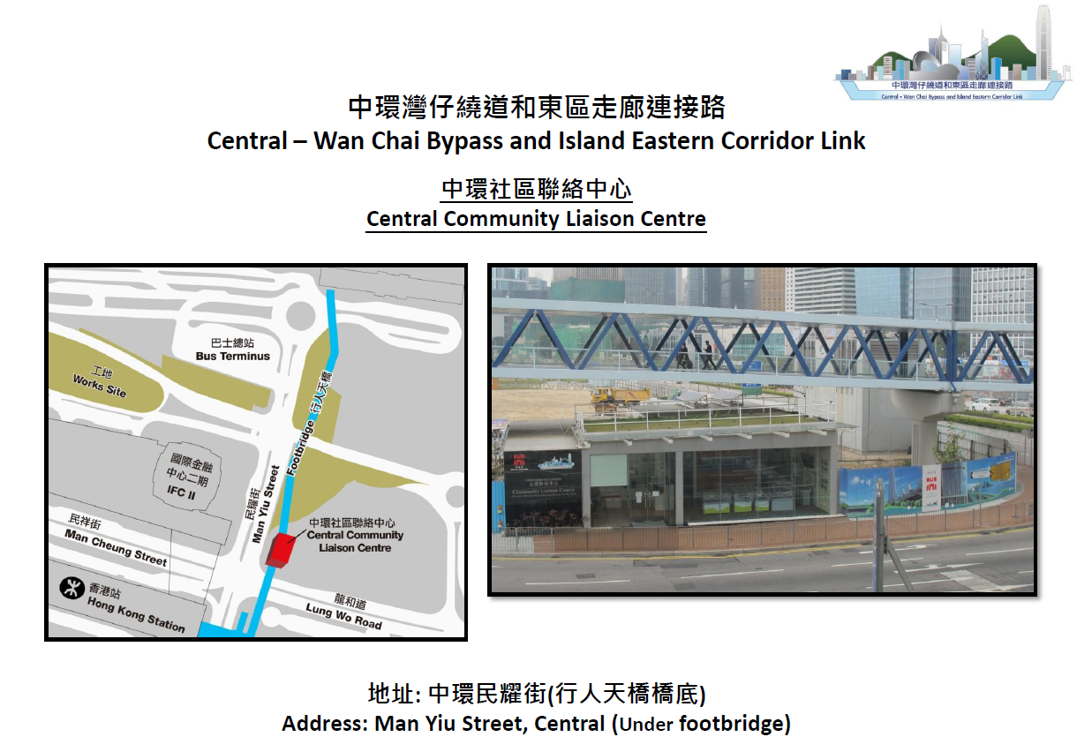
Site visit highlights:

- Overview of the Central – Wan Chai Bypass (CWB) project
- View the current works progress of the tunnel and/or bridge construction #

Proposed itinerary:
Time (am) | Itinerary
9:30 – 9:45 | - Gather and register at CLC
9:45 – 10:20 | - Introduction of CWB project and tunnel construction
10:20 – 10:35 | - Safety briefing
10:35 – 10:45 | - Group photo
10:45 – 11:45 | - Site walk #
11:45 – 12:00 | - Q & A session at Principal Resident Engineer’s Office
12:00 | - Site visit ends

# The actual works to be viewed and tour to the construction site are subject to weather, works progress and/ or other unforeseen situations on the day of the site visit.

Notice for Registration

- Visitors must adhere to requirements set out in the enclosed “Note on Site Visit”
- The number of participants is limited to 20, and priority will be given to EAHK members.
- All participants should be responsible for their own safety and belongings and need to sign an Undertaking upon registration.
- If typhoon signal no. 1 (or above) or the rainstorm warning (red or black) is hoisted or announced to be hoisted in effect within two hours prior to the start of the visit, the visit will be cancelled without further notice.
- Please complete and return the Registration Form to Simon FAN by email: info@ieausthk.org or FAX: 2430 9080 before 27 February 2016.
- Successfull applicants will only be confirmed by Simon FAN (phone : 9351 4963)

Engineers Australia Hong Kong Chapter: Technical Visit
“CWB Visit”
(5 March 2016) Registration Form
To: Simon FAN
From:

Name in full: |  |  | IEAust no.
Mobile : |  |  | Email:

Form of Undertaking
I fully understand and willingly accept that any invitation or permission gives to me to the tour shall be subject to but not exclusive to the following conditions:-

- Engineers Australia, Hong Kong Chapter (EAHK) and/or the organizer(s) shall owe no common duty of care to any visitor in respect of risks or dangers arising from the state of the facilities, or execution of any work or the carrying out of any activities therein.

- EAHK and/or the organizer(s) shall be absolved from all liabilities arising out of any incident or accidents causing loss, damage or personal injury (whether fatal or otherwise) howsoever caused to the visitor and whether the same is caused by negligence or not.

I am also fully aware that the signing of this Form of Undertaking by me shall indicate my acceptance of any risk or danger encountered due to the visit dated 5 March 2016.

Signature : ____________

Full Name: ______________

