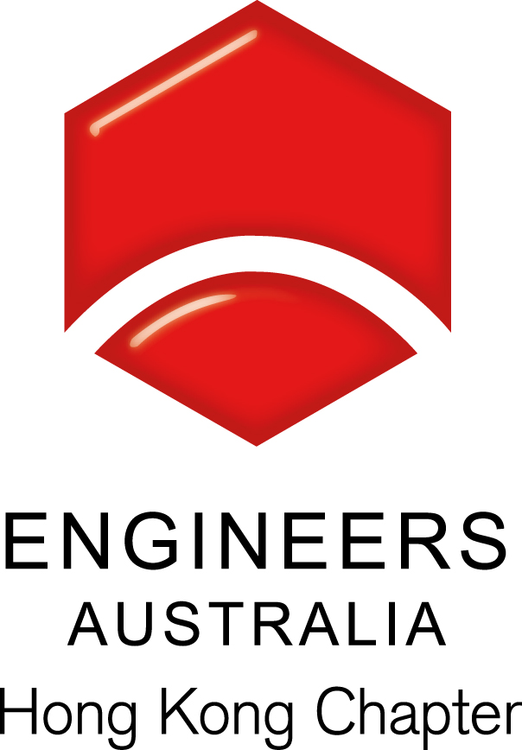
EAHK-ICE HKA Joint Evening Seminar

Topic: Corporate Social Responsibility: its past, its application within the Hong Kong Construction Industry and its possible future

Date, Time & Venue
3 November 2016 (Thursday): 6:30pm (Networking), 7:00pm (Start of Seminar)
Hong Kong Productivity Council
Theatre 1, 1/F HKPC Building
78 Tat Chee Avenue
Kowloon Tong
Hong Kong

Programme Highlights

Corporate Social Responsibility (CSR), the responsibility of a corporation for the impacts of its decisions on society and the environment, originated as a term, concept and academic topic in America in the 1950s. Since then, its definition and scope have been controversially debated within academe and broader society. The first part of the talk will very briefly trace its history over the past 60 years through to the publishing, in November 2010, of ISO 26000 “Guidance on Social Responsibility” which redefines “Social Responsibility” (“SR”) broadly, by reference to seven core SR subjects, and principles. ISO 26000 was intended to establish a common reference point for practitioners.
The second part of the talk is based on a paper presented in March 2015 at the 3rd ASEAN Australian Engineering Congress on Innovative Technologies for Sustainable Development and Renewable Energy and based on empirical research focused on the Hong Kong Construction Industry (“the HKCI”). This part of the talk will present the results of a research project to investigate which, if any, ISO 26000 CSR issues are relevant to the HKCI firms, whether such relevance is firm-size dependant; whether they are similar to construction industry firms elsewhere; and, whether they are strategically driven. One of the principal findings was that, for large construction contractors, the ISO 26000 SR issues relating to health and safety in the workplace and to the environment are the most relevant.
The third part of the talk is based on a paper presented in July 2016 at the Accounting and Finance Association of Australia and New Zealand Annual Conference and looks at the theory of CSR as it has been reported in the evolving CSR literature and academic research during the last decade when it has transitioned from a ‘whether or not to’ to a ‘how to’ implement CSR debate. The principal theoretical findings are that the progression of the CSR construct is both variegational (based on newly introduced theories) and progressive (predominantly building on existing theories) and that the predominant theoretical theme is based on stakeholder theory.
The conclusion of the talk will reflect on the use of the scientific method to investigate past events in the social sciences based on the results of these two research projects and the potential to extrapolate from the past into the future to forecast possible future developments in the field of CSR and business ethics generally.

Speaker: Dr. Norman Croker

Dr. Croker is the President of the Engineers Australia, Hong Kong Chapter

Continuing Professional Development (CPD)
Attending Engineers Australia members will be issued with a certificate acknowledging 1.5 hours of CPD.
A cost of HK$50 will be required for attendees requiring a CPD Certificate who are neither members of Engineers Australia nor members of ICE.

Remarks, Registration & Enquiries
If typhoon signal no. 3 (or above) or the rainstorm warning (red or black) is hoisted or announced to be hoisted in effect within two hours prior to the start of the talk, the talk will be cancelled without further notice.
The seminar is free of charge and all participants must be responsible for their own safety and belongings Please complete and return this form to Simon FAN by email: info@ieausthk.org or FAX: 2430 9080 before 1 November 2016. For enquiry, please contact Simon FAN on 9351 4963.

Engineers Australia Hong Kong Chapter: Technical Talk
Registration Form – (3 November 2016: 6:30pm to 8:30pm)
Registration Form

To: Simon FAN
From:
Name in full: |  |  | IEAust no.
Mobile : |  |  | Email:

