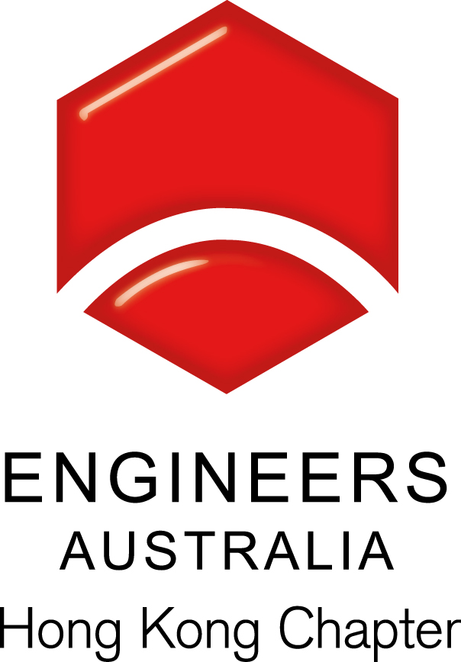
Technical Seminar
Air Movement for Energy-Efficient Comfort in Conditioned Spaces

Date, Time & Venue
17 October 2016 (Monday): 6:30pm (Networking), 7:00pm (Start of Seminar)
Hong Yip Training Centre at 5/F, New East Sun Industrial Bldg., No. 18 Shing Yip Street, Kwun Tong. Kowloon

Programme Highlights
This seminar will help participants learn about HVAC design strategy that pairs elevated air speeds with traditional air conditioning in order to achieve energy savings. The presentation will describe the additional design benefits from minimizing ductwork, lowering HVAC costs, improving ventilation rates and reducing condensation, as well as explain significant energy savings potential from de-stratifying a large open space. Speaker will also share some applications with ceiling fans to achieve thermal comfort and energy efficient, and introduce contribution to sustainable living programs like LEED and BEAM Plus.

Speaker: Matt Chan
Mr. Matt Chan is currently working as architectural engineer specialist in Big Ass Fans. He has been working with architects, engineers and listed companies for projects to increase thermal comfort. Matt delivered presentations on the subject of air movement and energy-efficiency to many professional associations and organizations like the Platinum Hong Kong.

Continuing Professional Development (CPD)
Attending Engineers Australia members will be issued with a certificate acknowledging 1.5 hours of CPD.
A cost of HK$50 will be required for attendees requiring a CPD Certificate who are neither members of Engineers Australia nor members of organisations affiliated with SAG.

Remarks, Registration & Enquiries
If typhoon signal no. 3 (or above) or the rainstorm warning (red or black) is hoisted or announced to be hoisted in effect within two hours prior to the start of the talk, the talk will be cancelled without further notice.
The seminar is free of charge and all participants must be responsible for their own safety and belongings Please complete and return this form to Simon FAN by email: info@ieausthk.org or FAX: 2430 9080 before 14 October 2016. For enquiry, please contact Simon FAN on 9351 4963.

Engineers Australia Hong Kong Chapter: Technical Talk
Registration Form – (17 October 2016: 6:30pm to 8:30pm)
Registration Form

To: Simon FAN
From:
Name in full: |  |  | IEAust no.
Mobile : |  |  | Email:

