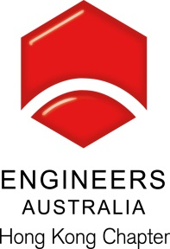
Seminar on “Australian Taxation”

Date, Time & Venue
8 June 1015 (Monday): 6:00pm (Networking), 7:00pm (Start of Seminar)

Hong Yip Training Centre at 5/F, New East Sun Industrial Bldg., No. 18 Shing Yip Street, Kwun Tong
(Please see attached loaction map)

Programme Highlights

- Australian tax residence issues discussion;
- Rental properties – what is the best tax structuring;
- How main residence exemption could apply and tax implication on relocating to Australia;
- Setting yourself up for retirement – tax issues on transferring money back to Australia
- 2015 Australia Federal Budget updates

Speaker:

Mr. Tommy IP

Tommy is the Managing Partner of Holistic Business Consulting Pty Ltd. He has over 18 years of experience in providing Australian tax and accounting solutions in Australia and Hong Kong.

Tommy is a member of CPA Australia, ICAA, Fellow of the HKICPA, a Registered Tax Agent in Australia and is a Chartered Tax Adviser.

Tommy is a regular guest speaker at the Australian Chamber of Commerce (HK) and Entrepreneur Club of Hong Kong, providing insights into starting or migrating business to Hong Kong. He is also a regular keynote speaker on taxation for seminars hosted by National Australia Bank and CPA Australia.

Continuing Professional Development (CPD)

Attending Engineers Australia members will be issued with a certificate acknowledging 1.5 hours of CPD.

Registration & Enquiries

The seminar is free of charge. Please complete and return this form to Simon FAN by email: info@ieausthk.org or FAX: 2430 9080 before 6 June 2015. For enquiry, please contact Simon FAN on 9351 4963.

Engineers Australia Hong Kong Chapter
Seminar on Australian Taxation
8 June 2015
7:00pm to 8:30pm
Registration Form

To: Simon FAN
From:

Name in full: |  |  | IEAust no.
Mobile : |  |  | Email:

