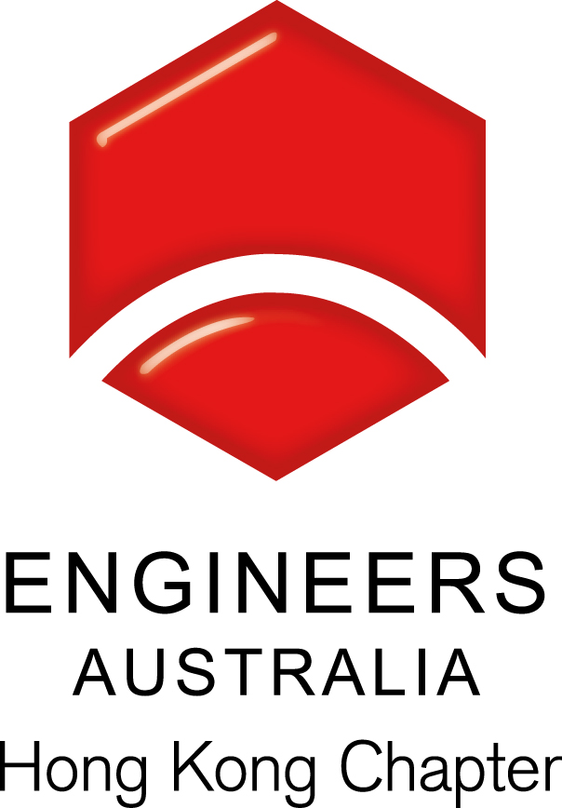
EAHK – Engineering Sports Leagues 2015
About
Young Engineers Australia Hong Kong (YEAHK) will once again participate in engineering sports leagues in 2015! We are delighted to invite all members to join our sports teams representing EAHK! We hope the sport games will offer members health benefits, worklife balance and networking opportunities in engineering community.

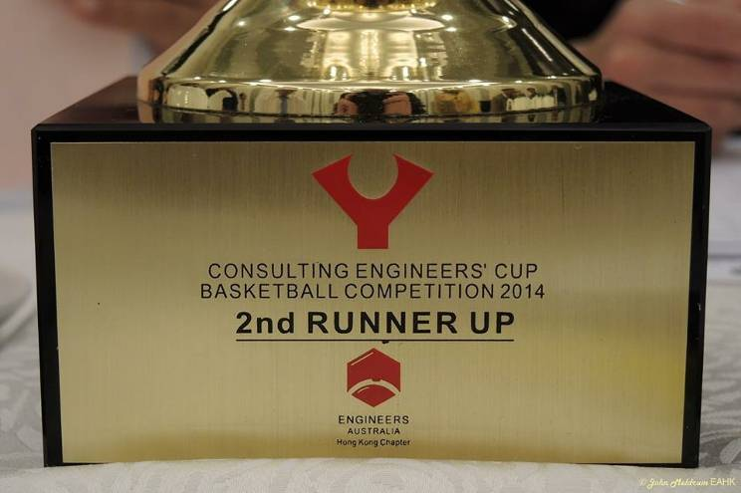

Basketball
League: Consulting Engineer’s Cup Basketball
Format: Season + Playoff (Indoor match)
Participant organisation: Atkins, Aecom, Black & Veatch, EAHK, Mannings, Meinhardt, Jacobs, Ove Arup, Hyder, Parsons Brinckerhoff, MTRC and HKIE
Start date: March till end of year
Match frequency: ~2 matches per month (typically weekday evenings or Saturday afternoon)

Soccer
League: Centuary Power Soccer League (Construction Cup)
Format: Double round-robin
Participant: Engineering institutions, construction and consultant firms
Start date: On-going
Match frequency: ~2 matches per month (typically weekdays 8pm-10pm)

Remarks, Registration & Enquiries
- Attendance to games is crucial for team success and enough players to play the game. YEAHK will subsidize portion of the game fees for all EA members.
- Play time during competition for each player may vary depending on skill level and game tactic.

Please complete and return this form to YEAHK by email: eahk.young@gmail.com or FAX: 2430 9080. For enquiries, please contact Marco LEE on 5182 4249 (soccer) and Julian NGAN on 6277 8114 (basketball).

Engineers Australia Hong Kong Chapter: Engineering Sport Leagues
Spring 2015
Registration Form

To: YEAHK
From:

Name in full: |  |  |  | IEAust no.
Mobile : |  |  |  | Email:
Sport:
Guest Player Name in full (if applicable):

