Seminar on Hong Kong Aviation Industry: Challenges and Opportunities
By Ir Dr Angus Cheung Report by: Ir Alan Wong

This seminar was successfully held on 26 June 2014. We were honoured to have Ir Dr Angus Cheung, Chief Executive Officer of China Aircraft Services Limited (CASL), as the speaker for this event. And a total of 30 participants attended this seminar.

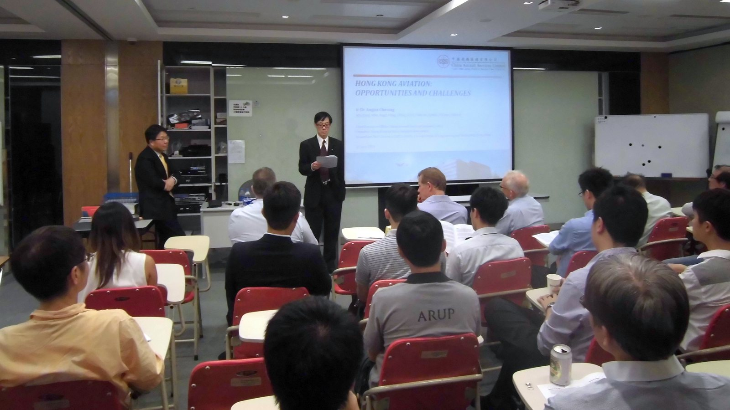

Dr Cheung provided a market overview, strength, opportunities and challenges of the aviation and maintenance, repair and overhaul (MRO) industry. He looked into market forecast and trends, with a focused discussion on the opportunities and challenges faced by different sectors in the industry. He also discussed how aviation contributes to the local economy and the aspects that Hong Kong surpasses other countries.

Aviation has made significant contributions to Hong Kong’s prosperity. Aviation and aviation-related tourism supported approximately HK$133 billion of GDP and 253,000 jobs in 2013, and air cargo throughput was around 4.12 million tonnes. Market forecasted that global passenger number in Asia Pacific region would rise from 2.98 billion in 2012 to 3.91 billion in 2017. Since 1998, the passenger volume has doubled in this world’s fastest growing region. Routes within or connected to China would be the single largest driver of growth, accounting for 24% of new passengers during the forecast period. It is expected that the world fleet size would be doubled in 20 years. The increase in fleet size in Asia Pacific region would be similar to the world trend. However, in 20 years the fleet size of China’s civil aviation would be increased by 3 folds.

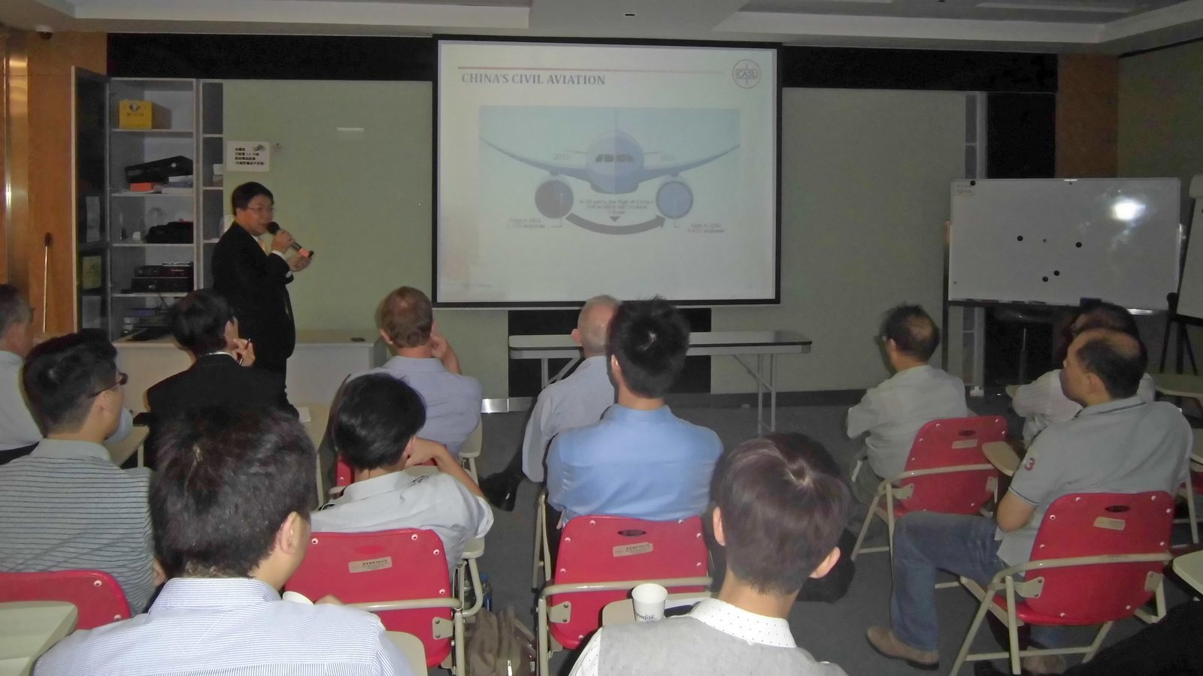

Dr Cheung pointed out that strength of Hong Kong included strategic geographical location as Hong Kong has excellent connectivity and accessibility. Hong Kong is an international air logistics hub - Hong Kong International Airport is one of the busiest airports in the world. Hong Kong is a free trade port, and has a world leading position for MRO services. Last but not least, Hong Kong is an international financial centre and training centre.

The speaker disseminated that MRO market balance shifting to the east in recent years has enhanced opportunities. Airlines have increased outsourcing. Low cost carriers are seeking MRO partners. Hong Kong’s central location has made distribution of aircraft spare parts to Asian customers more cost-effective. Bigger demand for aircraft parts would be resulted from aviation growth. Training organizations have launched new training courses for different new types of aircraft and have provided training of more aviation personnel such as engineers and pilots. Financial services are also provided for aircraft leasing and insurance business. Notwithstanding these, Dr Cheung cited the various challenges in aviation industry including shortage of pilots and engineers, competitions from other airports, airport saturation, airspace congestion and environmental issues.

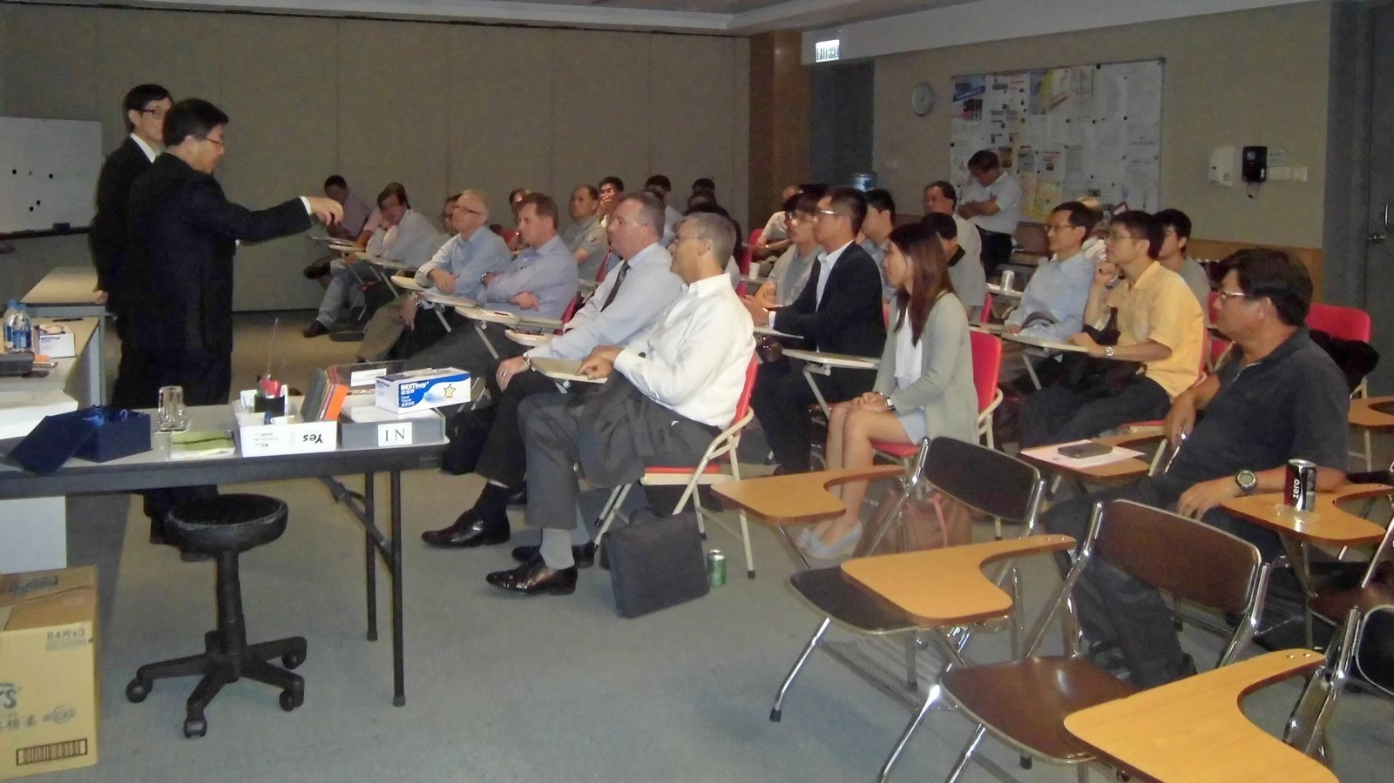

In the Q and A session that followed, the speaker answered a number of interesting and in-depth questions from the floor on aviation challenges and opportunities. We would like to express our sincere appreciation to Dr Cheung for his generous sharing of expertise and his great effort in delivering this seminar. His presentation was well received by the audience. Finally Ir Andrew Yuen presented a souvenir to Dr Cheung at the conclusion of the seminar.

