
Technical Visit to
Harbour Area Treatment Scheme

Date, Time & Place
Date: 2 August 2014 (Saturday) from 09:00 am to 12:00 noon
Site Location : at Stonecutters Island
Assembly Point: 8:30am at at the junction between Kent Rd. & somerset Rd., Kowloon Tong.

Background Information
The harbour area treatment scheme (HATS) is one of the largest ever sewerage infrastructure projects in Hong Kong. Stage 2 involves expansion of the existing treatment works and provision of new pumping station and sludge dewatering facility for chemically enhanced primary treatment (CEPT) at Stonecutters Island Sewage Treatment Works (SCISTW) to include the sewage from northern and south-western parts of Hong Kong Island and add disinfection and subsequent biological treatment to all the treated sewage at SCISTW.

The Harbour Area Treatment Scheme (HATS) Stage 2A Upgrading Works is the programme which will provide additional facilities to divert all remaining sewage from Victoria Harbour area to SCISTW for chemically-enhanced primary treatment and disinfection. Arup is upgrading eight Preliminary Treatment Works (PTWs) along Hong Kong Island and the Stonecutters Island Sewage Treatment Works (SCISTW), as well as the challenging interfacing works with other projects, existing treatment works operation, and provisions for the future HATS Stage 2B.

The advance disinfection facilities (ADF) at SCISTW commenced operation in late 2009, and are cleaning up effluent for early re-opening of bathing beaches at Tsuen Wan. The Interconnection Tunnel comprises of section A that is constructed by Earth Pressure Balanced type Tunnel Boring Machine and section B that is constructed by hand mined excavation method. The construction of both tunnels involves the use of Artificial Ground Freezing (AGF) technique, of which only very few local cases and experiences are available. The Effluent Tunnel is a deep drill and blast tunnel in hard rock. The deepest section of the tunnel is 90m below ground. The major challenges of the construction of this tunnel include water ingress and reduced rock quality due to encountering water-bearing fault zones.

HATS Stages 1 and 2A caters to the current and future needs of densely urbanised areas on both sides of Victoria Harbour – ultimate projected population of 5 million. HATS Stage 2A is being implemented to cope with the urbanised development of Hong Kong while bringing positive environmental benefits through preservation and enhancement of marine water resources such as benthic biodiversity and coral in Victoria Harbour.

Proposed Itinerary:
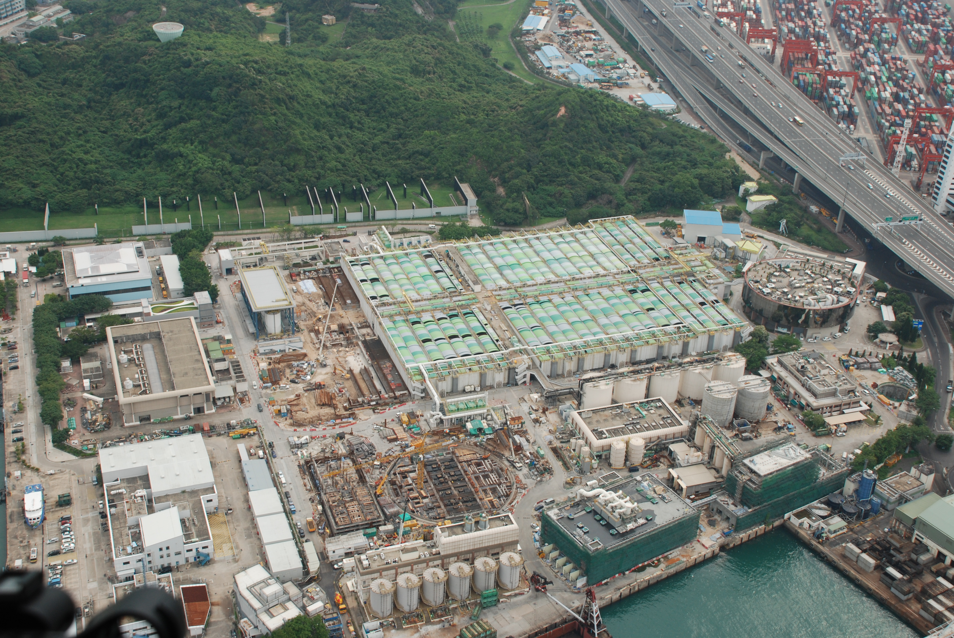
Take group photo and visit the Information Centre
- Visitor Centre at Existing MPS

- View the sedimentation tanks and FRP covers
1
2
3
4
- View the construction at extension of CEPT & MPS2
61
Pick up point
- View the DOU and Sludge Dewatering Facilities
5

Time | Location | Activities
09:30 | Arup’s ER office,  Conference room G5 | Coach arrival at Arup’s ER Office
09:30 – 10:15 | Arup’s ER office,  Conference room G5 | Presentation on HATS Stage 2A (40mins) and sharing on safety
10:15 – 11:20 | Leaving ER office and to SCISTW, gets into SCISTW through Gate No. 1  Drop off at front door of existing Main Pumping Station
10:15 – 11:20 | Station # 1 –Syscon Room |  | Visit Visitor Centre for HATS operations
10:15 – 11:20 | Station # 2 – Existing Sedimentation Tank |  | View the existing sedimentation tank and FRP cover
10:15 – 11:20 | Station #3 – Construction works for extension of CEPT tanks |  | General view of CEPT tanks extension
10:15 – 11:20 | Station #4 – Main Pumping Station |  | General view of Main Pumping Station
11:20 – 11:30 | Pick up at the MPS and return back to Arup ER office, Conference room G5
11:20 – 11:30 | Arup ER office, Conference room G5 | Closing session

Continuing Professional Development (CPD)
Attending Engineers Australia members will be issued with a certificate acknowledging 3 hours of CPD.

Notice for Registration
- The number of visitors is limited to 28, and priority will be given to EAHK members.
- All participants should be responsible for their own saftey and belongings and need to sign an Undertaking upon registration.
- For safety reasons, visit will be cancelled if any typhoon signal/red/black rainstorm warning is issued.
- Please complete and return the attached Forms to Simon FAN by email: info@ieausthk.org
or FAX: 2430 9080 on or before 21 July 2014.
- Successfull applicants will only be confirmed by Simon FAN (phone : 9351 4963)

Harbour Area Treatment Scheme
(Saturday, 2 August 2014) Registration Form

To: Simon FAN
From:
Name in full: |  |  |  |  |  | IEAust no.
 |  |  |  |  |  |  |  | Email:
Form of Undertaking

I fully understand and willingly accept that any invitation or permission gives to me to visit the Harbour Area Treatment Scheme shall be subject to but not exclusive to the following conditions:-
- Engineers Australia, Hong Kong Chapter (EAHK) and/or the organizer(s) shall owe no common duty of care to any visitor in respect of risks or dangers arising from the state of the facilities, or execution of any work or the carrying out of any activities therein.

- EAHK and/or the organizer(s) shall be absolved from all liabilities arising out of any incident or accidents causing loss, damage or personal injury (whether fatal or otherwise) howsoever caused to the visitor and whether the same is caused by negligence or not.
I am also fully aware that the signing of this Form of Undertaking by me shall indicate my acceptance of any risk or danger encountered due to the visit dated 2 August 2014.

Signature:

