
ENGINEERS AUSTRALIA, HONG KONG CHAPTER

Visit ＴＨＥ ＥＬＤＥＲＳ
Santa Claus Coming to Town (暖意歡騰迎聖誕)
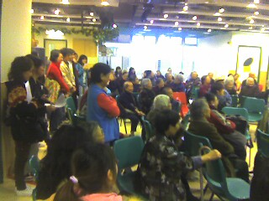
Date and Location:-
14 December, 2014 (9:00-12:00)
Aberdeen Kai-fong Welfare Association Social Service
Address: Hall, 1/F, 180B Aberdeen Main Road, Aberdeen.
The assembly time is 8:45 at the Hall, and participants should arrange their own
transport to the venue. (Location Map is attached h/w for your reference.)

Objective:
To celebrate the coming winter solstice and Christmas, EAHK will send out warm
regards and gifts (arrange by the Kai-fong Welfare Association) to community elders
and caregivers in Aberdeen through home visits. So we need volunteers to join this
meaningful task.
For registration, please complete and return the underneath form by email:info@ieausthk.org or FAX 2430 9080 before 12 December 2014.
For enquiry, please call Simon FAN on 9351 4963

Visit to the elders (14 December 14) Registration Form
TO: Mr. Simon FAN

From : ________________ IEAust No.

Phone No._______________ email ___________________

Remarks: All volunteers are required to contact the team leader, Mr. Andrew Yuen
(phone:92449686) upon arrival the hall.


南區長者綜合服務處
南區寒冬送暖金絲帶大行動2014

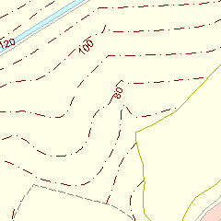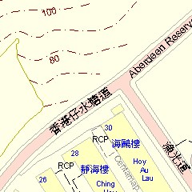
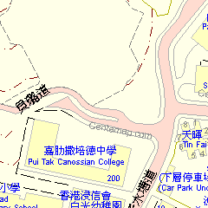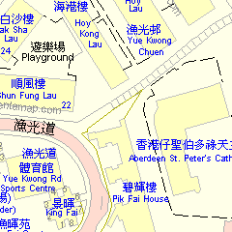
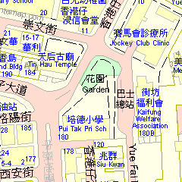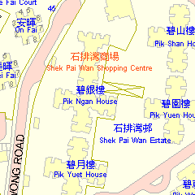
集合地點：本會總部禮堂 ( 香港仔大道180號B一樓 )

