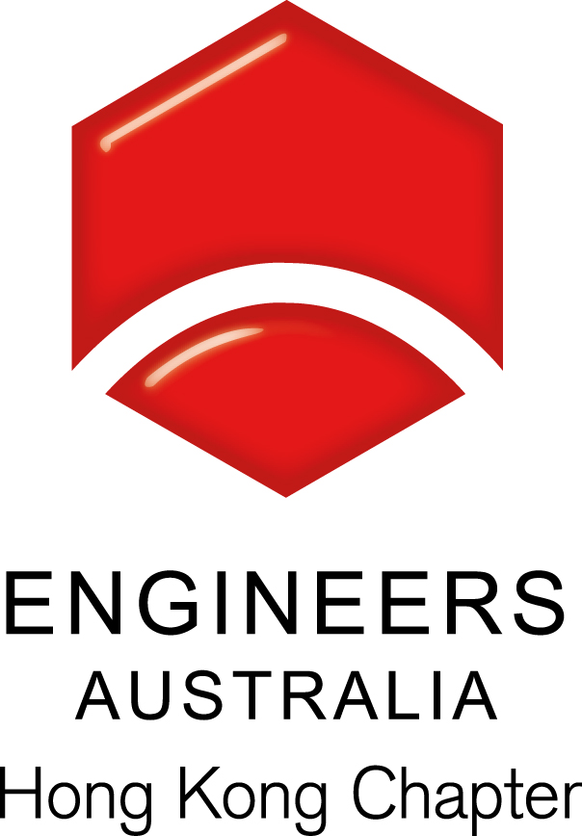
HKIE YMC Joint Society Christmas Party 2014
“Night of Uniform”

Event details:
HKIE Young member Committee (HKIE YMC) is inviting all engineers to join their annual joint society Christmas Party. Young Engineers Australia Hong Kong (YEAHK) as a supporting group of this event, we would like to invite all members (including all EA members, members of the SAG and guests from members) to share a great party night.

Date: 13 December 2014 (Saturday)
Time: 08:00pm to 12:00am
Venue : Habitat Lounge – 29/F QRE Plaza, 202 Queen’s Road East, Wan Chai灣仔皇后大道東 202號 QRE Plaza 29樓
Dress Code : Uniform
Foods and beverages: Unlimited drinks and light refreshment will be provided for first three hours.
Entertainment: Ice-breaking, mass game, lucky draw, drinks rivalry, Best Dressing Prize giving of the night and more.
Fee: HKD $360 (to be collected by HKIE YMC
Registration Cut-off date: 08 December 2014 (Monday)
Remarks: Bag keeping service will not be available.

Notice for Registration

- This event is organized by the HKIE YMC and is opened to members of Engineers Australia..
- All participants should be responsible for their own saftey and belongings..
- Interested party could send back the below registration to Simon FAN by fax no.24309080
or email:info@ieausthk.org

Name : IEAUST no.

Mobile Phone No |  |  |  |  |  | Email:

