
YEAHK BIKE RIDE BEFORE
YEAR-END BBQ GATHERING
Date, Time & Place
Date: 6 December 2014 (Saturday) from 11am to 1:30pm
Destination: Bahia Chung King BBQ Restaurant, 101 Lung Mei Village, Ting Kok Road, Tai Po
Assembly Point: Goodluck Bike Shop, Shatin Park Bike Kiosk No.2, 1 Yuen Wo Road (River side), Shatin (See next page for detailed location)

Background Information
This is a biking event organized by YEAHK. It is open to everybody (including all EA members, members of the SAG and HKIE YMC). The ride will end in the afternoon (at about 1:30pm) at the Bahia Chung King BBQ Restaurant opposite the Lung Mei beachfront at Tai Po, with the intention that majority of participants would join the Year-end BBQ hosted by EAHK, which is also open to all guests (see separate attachment “BBQ.doc”).

Riders may chose to keep their bike hire until it ends on 7pm, and further explore the bike trail along the Plover Cove Dam. Riders may return the bike either in Tai Mei Tuk (near the BBQ venue) or chose to ride back to return the bike in Shatin (before 7pm).

Riders will meet in front of the Good Luck Bike Shop (see photo next page) at 11:00am for bike rental registration, with targeted departure time on 11:20am. The ride would be mostly on flat biking trail, and the journey is expected to take less than 2 hours.
(Route info: https://www.google.com/maps/dir/22.3797966,114.1906214/%E5%B7%B4%E5%B8%8C%E9%9B%85%E6%B5%B7%E7%81%A3%E9%87%8D%E6%85%B6%E7%87%92%E7%83%A4/@22.4234774,114.192654,13z/data=!4m9!4m8!1m0!1m5!1m1!1s0x0:0xae9f81ec8dbf75e3!2m2!1d114.228427!2d22.47232!3e2 )

Charges
EAHK Members/SAG/HKIE-YMC : HK$40/head
Guests : HK$80/head
Charges include bicycle day hire (11:20am – 7pm). Bike may be returned back to Good Luck Bike Shop in Sha Tin or Partnering Bike shop in Tai Mei Tuk before hiring period ends.
Route map:
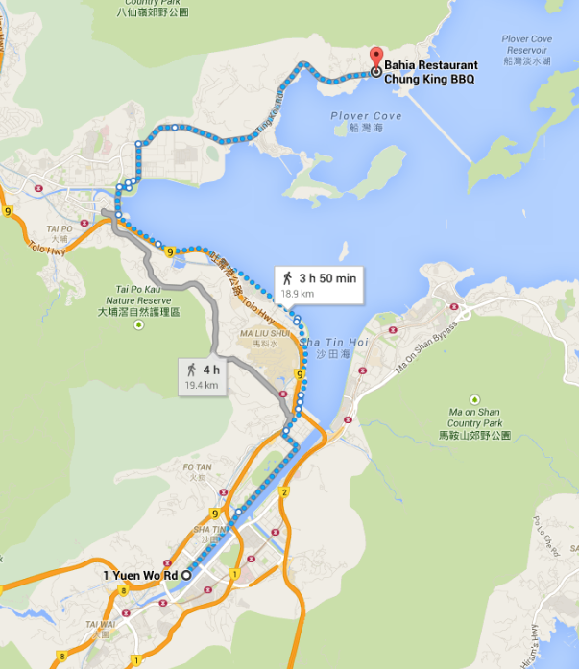

Assembly Point on 11am, 6th December 2014:
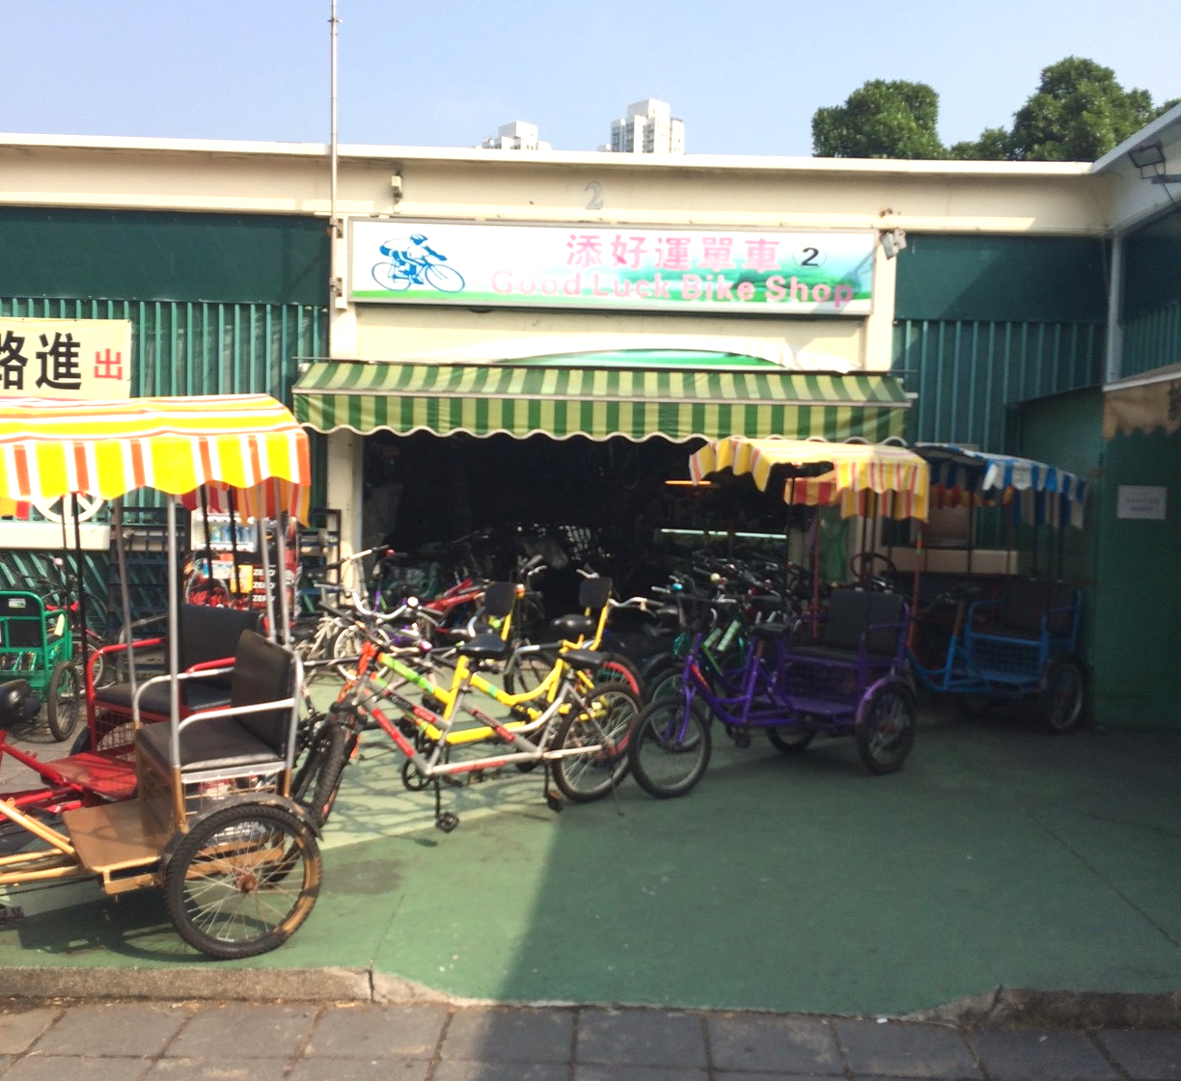
Notice for Registration
- All participants should be responsible for their own safety and belongings and need to sign an Undertaking upon registration.
- If typhoon signal no. 1 (or above) or the rainstorm warning (red or black) is hoisted or announced to be hoisted in effect within two hours prior to the start of the visit, the visit will be cancelled without further notice.
- Please complete and return the attached Forms to by email: eahk.young@gmail.com
or FAX: 2430 9080.
- Successfull applicants will only be confirmed by email (for enquiries please phone : 9622 3351)

Engineers Australia Hong Kong Chapter: “YEAHK Ride before Year End BBQ”
(6 December 2014) Registration Form

To: YEAHK
From:

Name in full: |  | IEAust no. / Guest:
Mobile : |  | Email:

Form of Undertaking

I fully understand and willingly accept that any invitation or permission gives to me to the riding event shall be subject to but not exclusive to the following conditions:-

- Engineers Australia, Hong Kong Chapter (EAHK) and/or the organizer(s) shall owe no common duty of care to any visitor in respect of risks or dangers arising from the state of the facilities, or execution of any work or the carrying out of any activities therein.

- EAHK and/or the organizer(s) shall be absolved from all liabilities arising out of any incident or accidents causing loss, damage or personal injury (whether fatal or otherwise) howsoever caused to the visitor and whether the same is caused by negligence or not.

I am also fully aware that the signing of this Form of Undertaking by me shall indicate my acceptance of any risk or danger encountered due to the event dated 6 December 2014.

Signature : ____________

Full Name: ______________

Date :

