
Technical Visit to
Reconstruction, Improvement and Rehabilitation of Kai Tak River
from Wong Tai Sin Police Station to Tung Tau II Estate
(Contract No.DC/2011/04)

Date, Time & Place
Date: 1 November 2014 (Saturday) from 09:30 am to 12:15 pm

Assembly Point: 8:30AM at the junction between Kent Rd. & Somerset Rd., Kowloon Tong

Project Description
The drainage capacity of Kai Tak River in Wong Tai Sin is inadequate to meet the current flood protection standards. Recent significant flooding events that occurred in June 2006, July 2008 and June 2010 severely affected the traffic networks in the Wong Tai Sin area. There is an urgent need to remove the bottlenecks and improve the drainage capacity of the River.

The alignment of the Kai Tak River is parallel to Choi Hung Road which is an important local distributor with dual two traffic lanes. Both sides of the River are fully occupied by existing residential properties and roads - thus available land for improvement works is limited. The proposed works under construction include a box culvert underneath the carriageway of the adjacent Choi Hung Road and a complete reconstruction of the junctions at Tai Shing Street and Shatin Pass Road. The construction works will be carried out in stages so as to maintain the heavy traffic flow with minimal disruption to the road users. Construction of the new culvert and other upgrading works necessitate phased partial or full closure of sections of the traffic lanes of Choi Hung Road and thus a series of temporary traffic management schemes have to be deployed to cater for these scenarios by diverting/shifting traffic flows to maintain vehicular movements and capacities during construction. Upon completion, the proposed works will improve the living environment through enhancement of the local townscape, provision of a scenic location for public leisure enjoyment as well as fostering closer connection with adjacent areas.

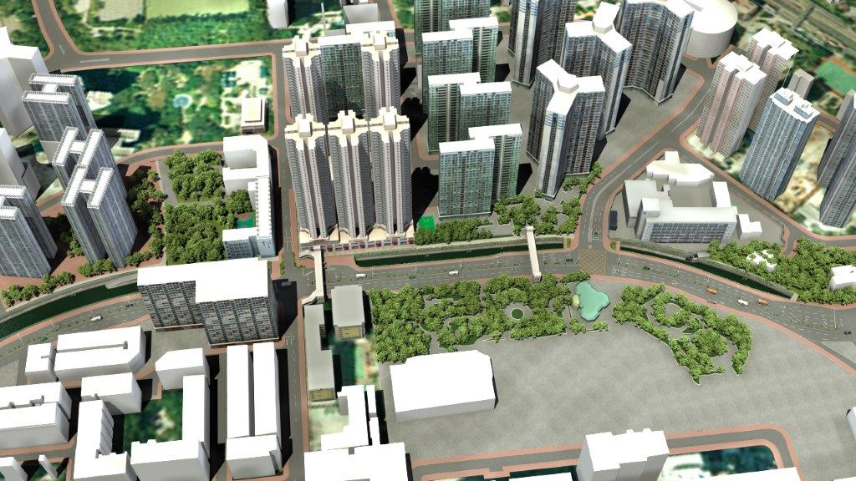 | 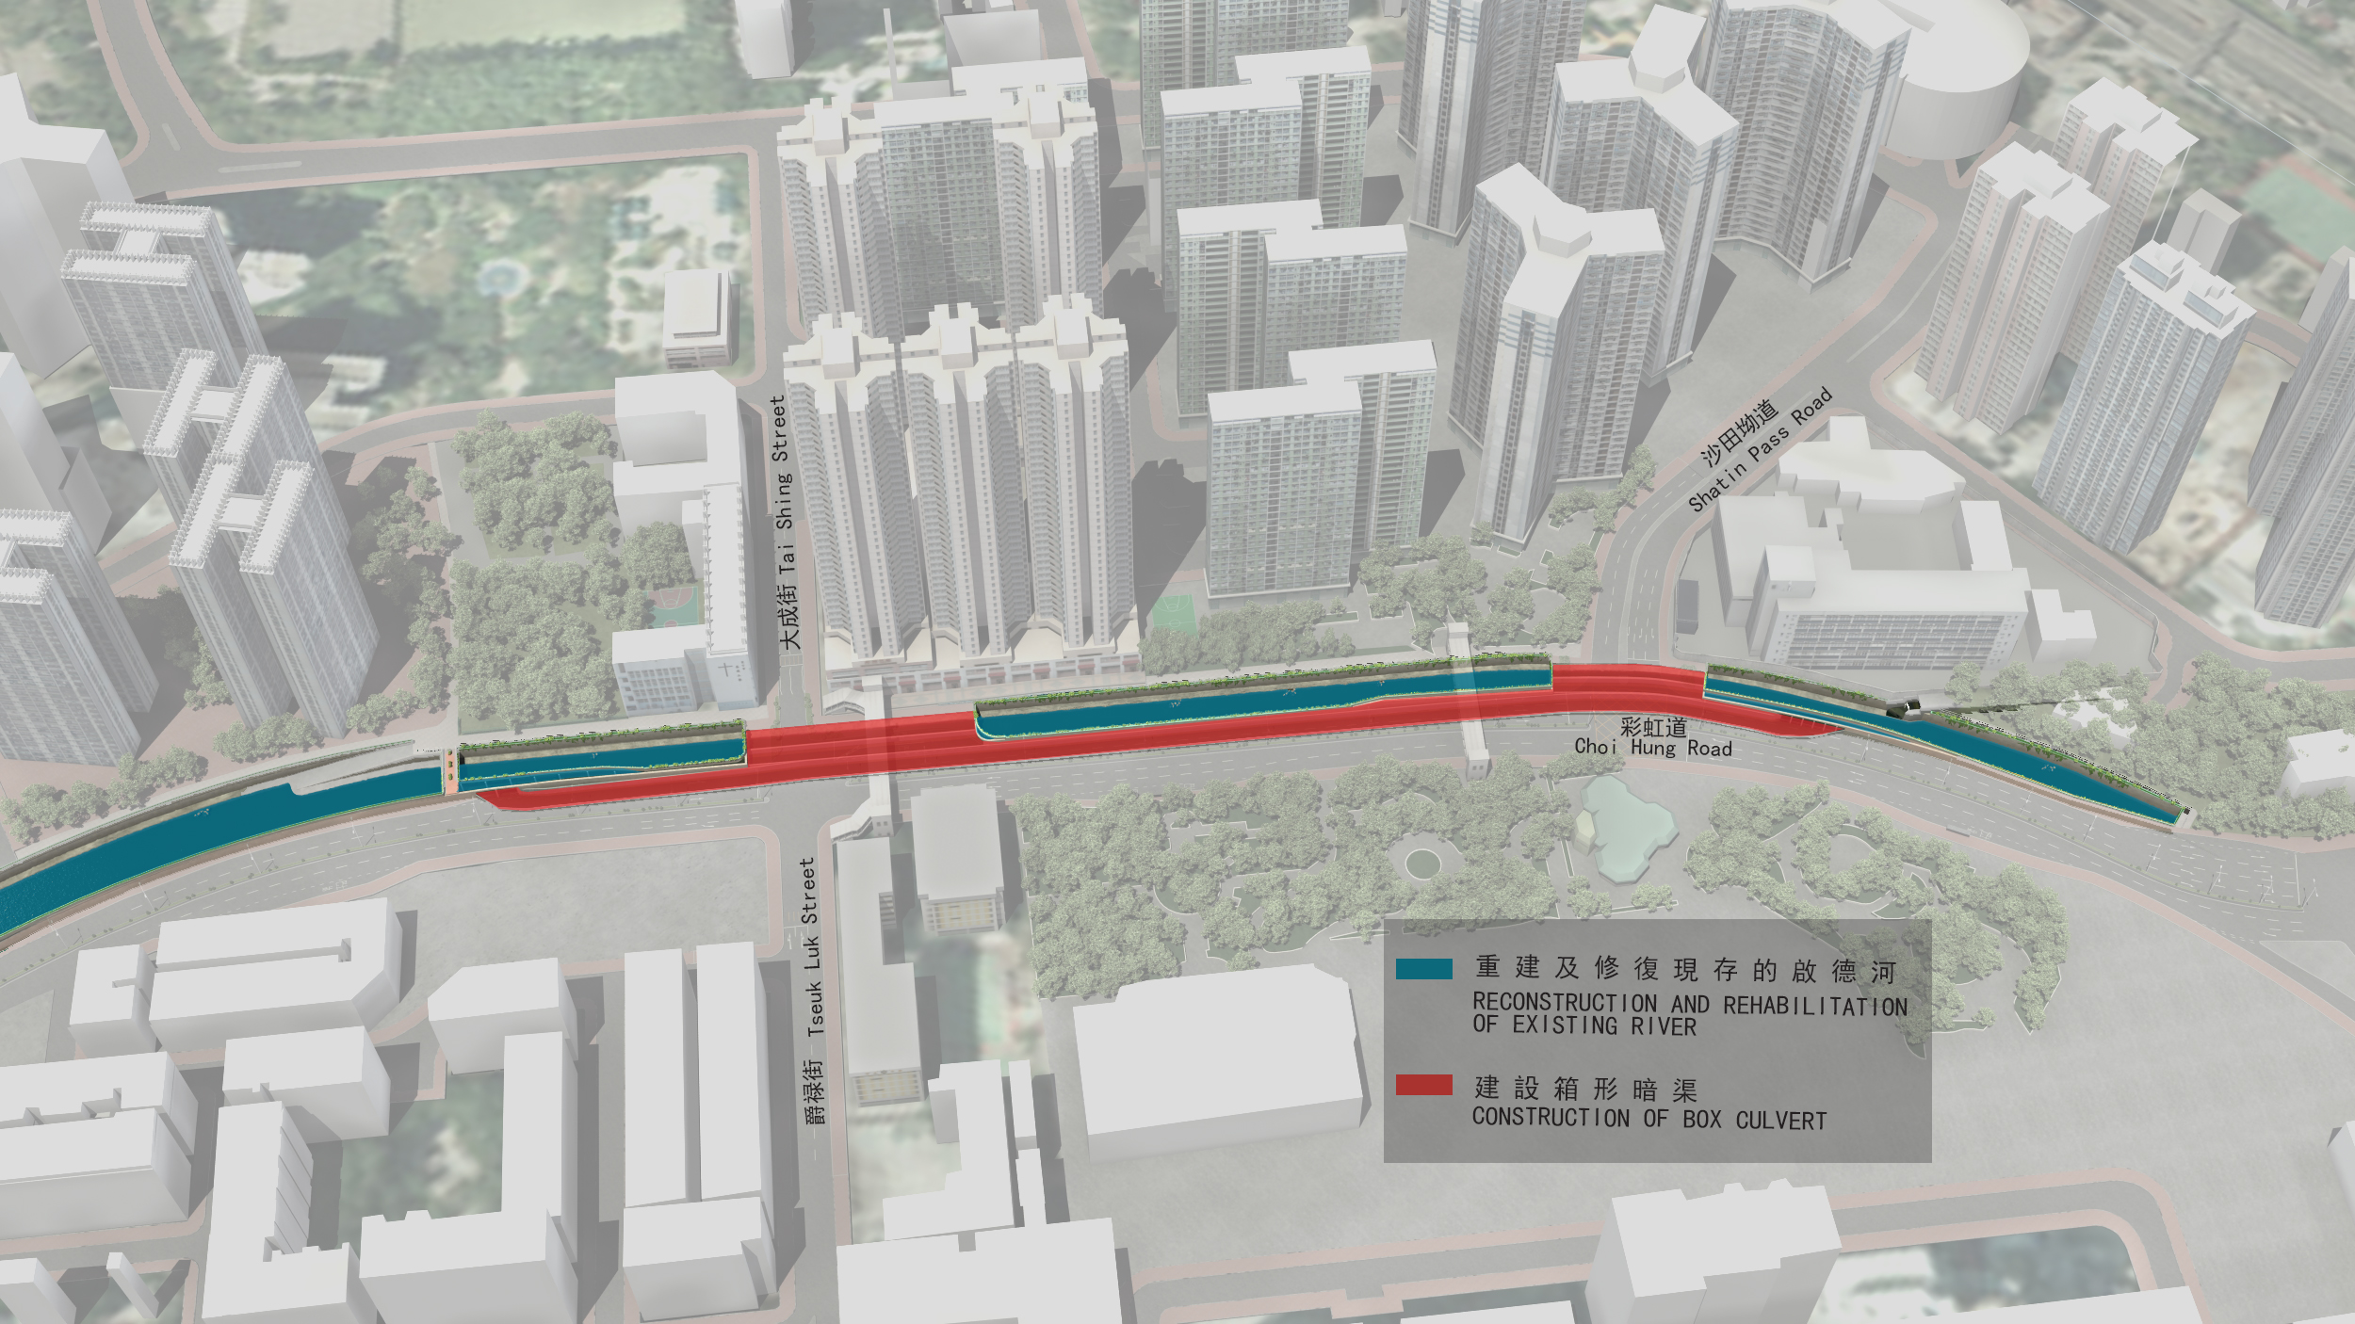
Site Visit Itinerary
A brief presentation will be delivered to the participants to introduce the progress of the construction. Then the project team will arrange site tour for the participants.

Continuing Professional Development (CPD)
Attending Engineers Australia members will be issued with a certificate acknowledging 2.5 hours of CPD.

Notice for Registration
- The number of visitors is limited to 25, and priority will be given to EAHK members.
- Participants must bring their own protective footwear.
- All participants should be responsible for their own saftey and belongings and need to sign an Undertaking upon registration.
- For safety reasons, visit will be cancelled if any typhoon signal/red/black rainstorm warning is issued.
- Please complete and return the attached Form to Simon FAN by email: info@ieausthk.org
or FAX: 2430 9080 on or before 21 October 2014.
- Successfull applicants will only be confirmed by Simon FAN (phone : 9351 4963)

Site Visit to Contract No.DC/2011/04)
(Saturday, 1 November 2014) Registration Form

To: Simon FAN
From:
Name in full: |  |  |  |  |  | IEAust no.
Phone No. |  |  |  |  |  |  |  | Email:
Form of Undertaking

I fully understand and willingly accept that any invitation or permission gives to me to visit the Contract No.DC/2011/04) shall be subject to but not exclusive to the following conditions:-
- Engineers Australia, Hong Kong Chapter (EAHK) and/or the organizer(s) shall owe no common duty of care to any visitor in respect of risks or dangers arising from the state of the facilities, or execution of any work or the carrying out of any activities therein.

- EAHK and/or the organizer(s) shall be absolved from all liabilities arising out of any incident or accidents causing loss, damage or personal injury (whether fatal or otherwise) howsoever caused to the visitor and whether the same is caused by negligence or not.
I am also fully aware that the signing of this Form of Undertaking by me shall indicate my acceptance of any risk or danger encountered due to the visit dated 1 November 2014.

Signature:

