Seminar on Lift and Escalator Safety and Regulation
By Alan Wong

The captioned seminar was successfully held on 18 July 2013. The speaker of this seminar was Ir Chui Wai Sing, Chief Electrical & Mechanical Engineer of Electrical and Mechanical Services Department (EMSD). And a total of 50 members attended this seminar.

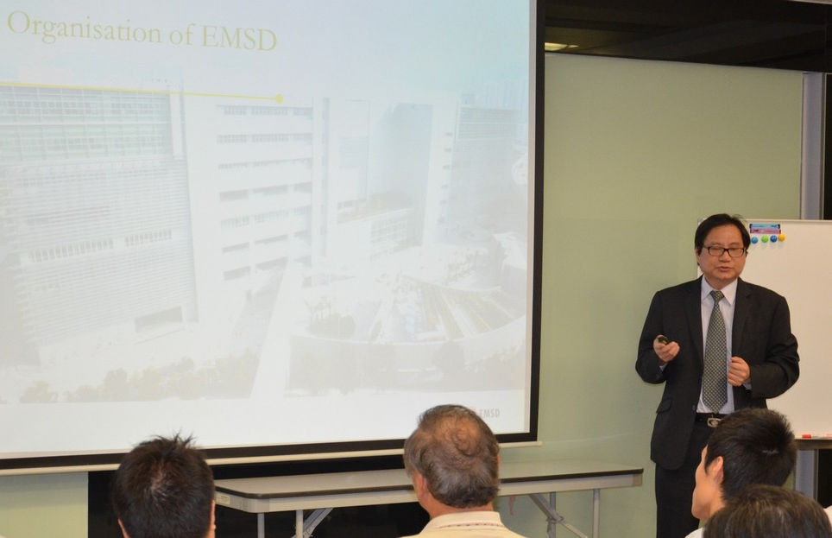
Ir Chui disseminated that existing lifts and escalators in Hong Kong have been installed in different decades. They were installed to the level of technology appropriate at the time. However, rapid technology advancement in recent years has resulted in existing lifts and escalators installed in the past to become less comparable with the state-of-the-art technology of modern plants. Although they are safe if examined in a periodic interval and maintained in a proper manner, there is room for improvement to make them safer, more reliable and more comfortable.

Ir Chui pointed out that there are approximately 60,000 lifts and 8,000 escalators in Hong Kong. The lift density in Hong Kong is approximately 1 lift per 116 persons, which could be the highest in the world. The safety of lifts and escalators, therefore, is very important. To enhance safety of lifts and escalators, the new Lifts and Escalators Ordinance (Chapter 618) was put into full operation on 17 December 2012, and the previous Lifts and Escalators (Safety) Ordinance (Chapter 327) was repealed on the same date.. This new ordinance, which is applicable to all lifts and escalators in Hong Kong, strengthens the registration regime, increases the penalty levels of offences, extends the application of the legislation and introduces measures to enhance operational efficiency and enforcement effectiveness.

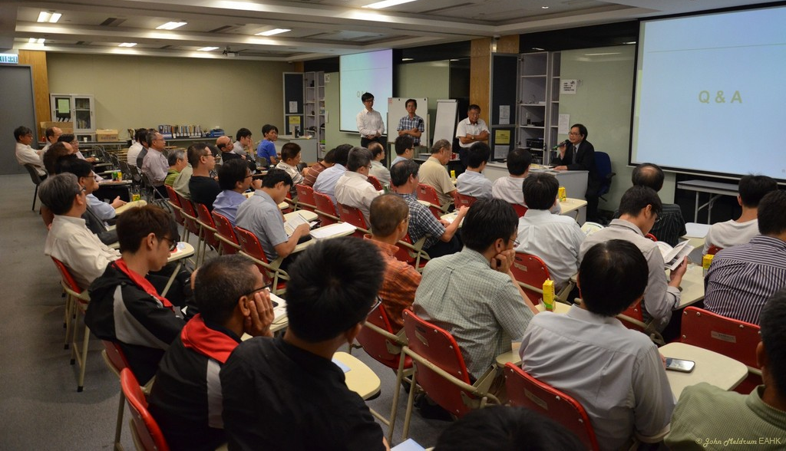

Moreover, EMSD issues Code of Practice for Lift and Escalators and guidelines, approves lifts and escalators, issues use permits, investigates incidents and conducts regular audit inspections to enhance safety of lifts and escalators. Only registered contractors are qualified to carry out lift works and escalator works. Also only registered lift / escalator engineers are qualified to carry out examination of lifts / escalators and certify their good design and working order before putting into use.
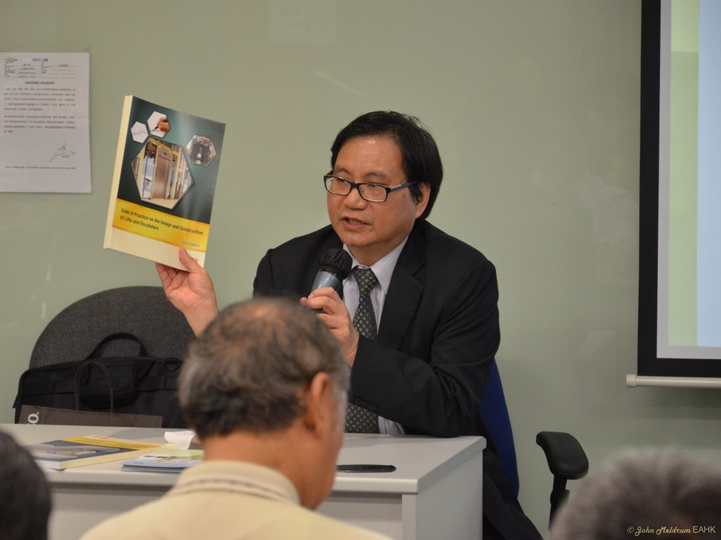
Furthermore, Ir Chui advised that, in order to ensure safety of older lifts, preventive maintenance and repairs shall be arranged on a continuing basis. Regular maintenance shall be carried out by registered lift contractor to proactively identify improvement needs for existing lifts. If any of the improvement need is identified, it is essential to implement modernization works in a prompt manner. Ir Chui described seven solutions with the greatest potential benefits for safety, reliability and comfort enhancement in older lifts. Such solutions for enhancement of older lifts include installation of one or more of the following -- a double brake system, an unintended car movement protection device, an ascending car over speed protection device, car door mechanical lock and door safety edge, an intercom and closed-circuit television (CCTV) system, an obstruction switch to protect suspension ropes and automatic rescue devices. Ir Chui recommended to implement these solutions to upgrade the existing lifts to a level of technology comparable to today’s state-of-the-art standards so that older lifts would be more reliable and comfortable for riding.

An interactive question and answer session was held after the presentation. Some members asked whether it is mandatory to upgrade the older lifts to the current standard, and what appropriate interval for lift inspection shall be, which was clarified by Ir Chui. This presentation provided participants a valuable opportunity to explore various engineering solutions to improve the standards of obsolete lifts, showing the heart of engineering, which is the duty of care on the safety of lift users. Finally, our President proposed a vote of thanks to Ir Chui and thanked the participants for their support.

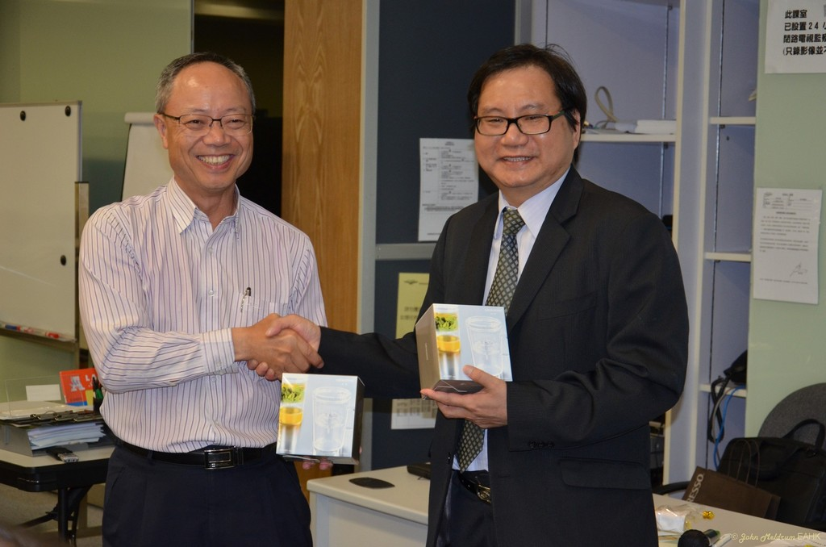

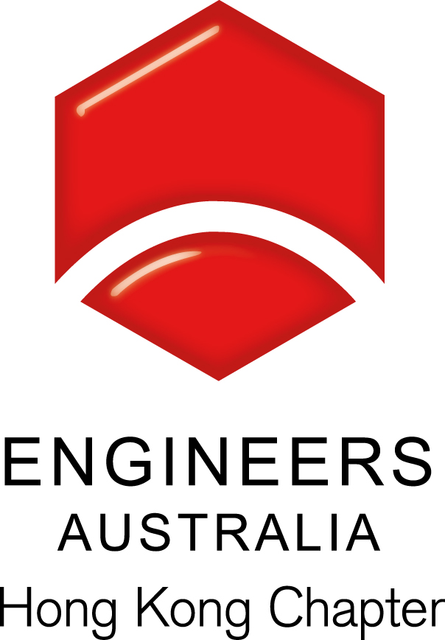
Seminar for Lift & Escalator Safety & Regulation
Date, Time & Venue
18 July 2013 (Thursday): 6:00pm (Networking), 7:00pm (Start of Seminar)
Hong Yip Training Centre at 5/F, New East Sun Industrial Bldg., No. 18 Shing Yip Street, Kwun Tong, Kowloon

Programme Highlights
Lifts and escalators are important mode of transport we use every day in Hong Kong, a city with the highest density of tall buildings. The new Lifts and Escalators Ordinance (Chapter 618) ("the new Ordinance") have come into force and repealed the previous Lifts and Escalators (Safety) Ordinance (Chapter 327) since 17 December 2012. The Ordinance introduces a series of enhanced control measures including extending the coverage of the legislation; strengthening the registration regime of personnel engaged in lift and escalator works; increasing the penalty levels of offences; and improving the regulatory processes to enhance efficiency.
With rapid growth of Hong Kong in the past decades, lifts and escalators installed in different years conformed to the level of technology appropriate at the time. Technological advancement in recent years means that existing lifts and escalators installed in the past are below the state-of-the-art technology of modern plants. There is room for improvement to make them more safe, reliable and comfortable.
In the talk, the speaker will introduce the new Ordinance, the regulation of lift and escalator safety in Hong Kong, and discuss solutions for aged lifts.

Speakers:
Ir. CHUI Wai-sing is currently the Chief Electrical & Mechanical Engineer in the General Legislation Division in the Electrical & Mechanical Services Department (EMSD), Government of the HKSAR. Ir CHUI joined the EMSD after his graduation in Associateship in Mechanical Engineering at Hong Kong Polytechnic in 1982. He has over 30 years of experience in various design, operation and maintenance of various electrical and mechanical plants in Electrical and Mechanical Service Department and Drainage Services Department. He was appointed as Chief E&M Engineer of the General Legislation Division in EMSD in December 2010, and he is responsible for ensuring safe operation of lifts, escalators, amusement rides, aerial ropeways, builders' lifts and tower working platforms.

Special Highlights
Light refresement will be served during the event to the Engineers Australia members .

Continuing Professional Development (CPD)
Attending Engineers Australia members will be issued with a certificate acknowledging 1.5 hours of CPD.

Registration & Enquiries

The seminar is free of charge. Please complete and return this form to Simon FAN by email: info@ieausthk.org or FAX: 2430 9080 by 16 July 2013. For enquiries, please contact Simon FAN on 9351 4963.

Engineers Australia Hong Kong Chapter: Technical Talk
“Lift & Escalator Safety & Regulation”
18 July 2013: 6:00pm to 8:00pm
Registration Form

To: Simon FAN
From:

Name in full: |  |  | IEAust no.
Mobile : |  |  | Email:

