Technical Visit to South Island Line MTR 903 Project

by Simon Tong

The South Island Line is an important rail link between the northern and southern parts of Hong Kong Island. The MTR 903 project involves the construction of two above-ground stations at Ocean Park and Wong Chuk Hang together with 2.1 km of viaduct that forms the elevated section of the railway, and a 246m long bridge over the Aberdeen Channel.

EAHK organized a technical visit to the site on 29 June 2013 and it was attended by 25 members. Paul Freeman, Project Director of Leighton Contractors Asia Ltd, first addressed the participants on the safe working procedures throughout the entire construction which involve substantial amount of heavy lifting, working at height and crane movements. He pointed out that all construction works must be carried out in accordance with the approved method statements with stringent supervision. The necessary permit-to-move and permit-to-dig are implemented successfully. He also stressed that good coordination and communication among various levels of engineering staff are vital to attaining a safe working environment.

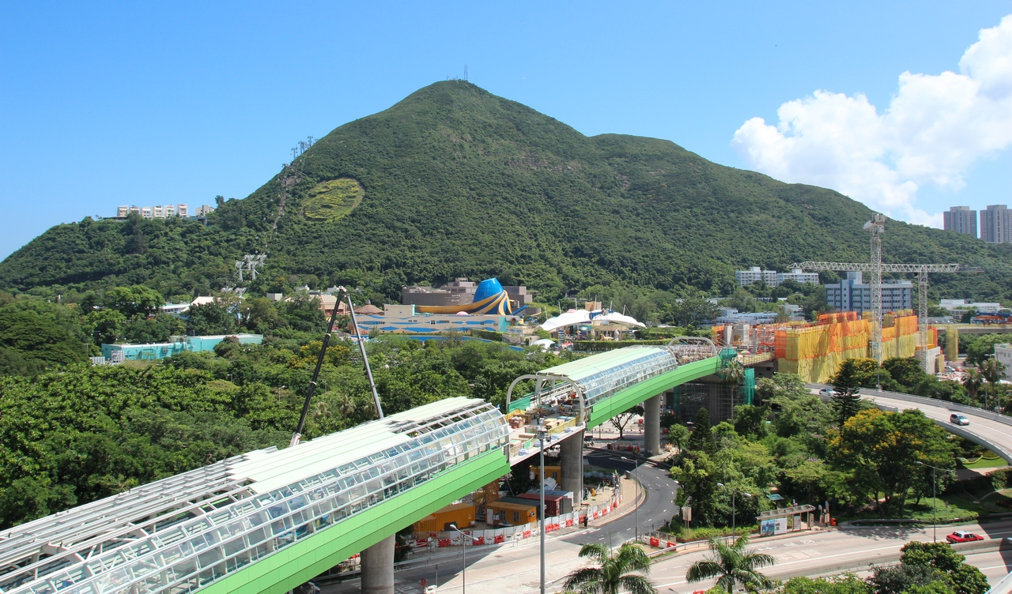

He then explained the use of value engineering in this target cost project, and cited examples of successful application such as re-designing the pile foundations to reduce the number of bored piles and the footprint of pile cap. This is particularly useful in an area bounded by traffic on all sides. Another example is to re-design the number of portal frames around a drainage nullah, where there are restricted working conditions during the rainy seasons ( since some piles have to be installed within the nullah and as such the nullah has to be widened.).

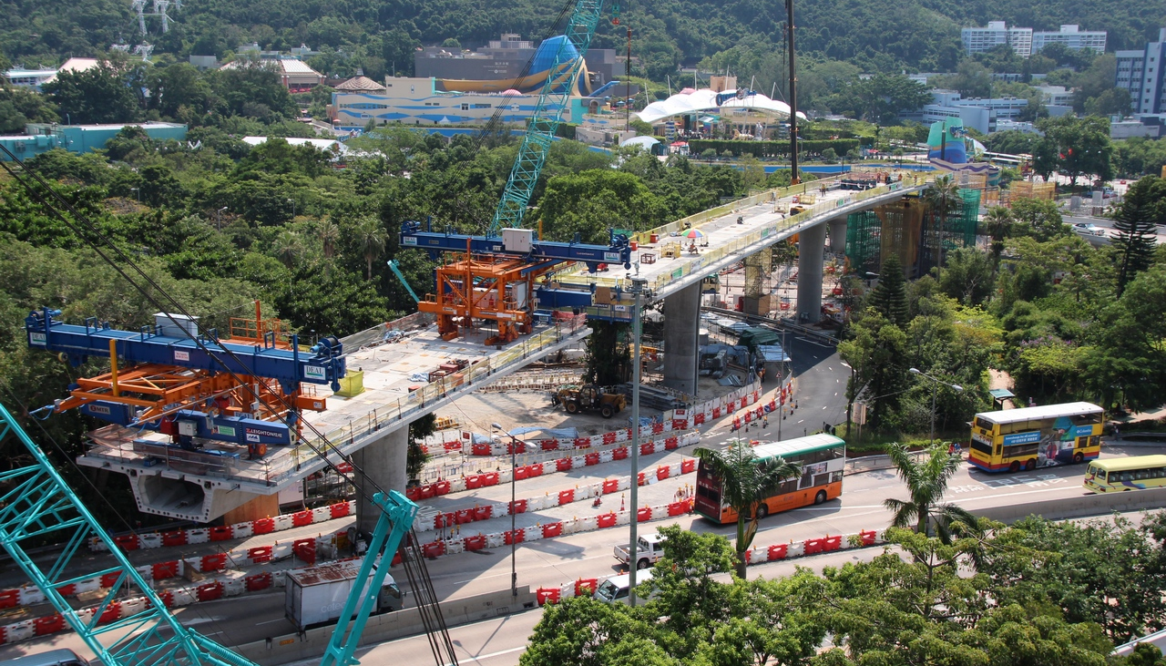

The elevated viaduct has three sections with the first section crossing several busy roads coming out of Aberdeen Tunnel. The viaduct is designed as a precast segmental balanced cantilever structure, and Leighton used a beam and winch to install and stress the segments. This has proven successful due to its flexibility to erect the segments in a non lineal sequence if required as compared to the erection gantry method.

The participants were then taken out to see the construction of the Ocean Park Station and the elevated walkway linking the entry plaza of the Park. The party also observed the construction of noise barriers and noise enclosures over the elevated viaducts. After the site walk the participants were led to the innovative green roof on top of the project office for group photos.

The visit ended with a fruitful and interactive Q&A session. Our members have learned the many important facets of project management in a complex railway project. We would like to express our gratitude to Paul Freeman and his staff for conducting this interesting and informative technical visit.

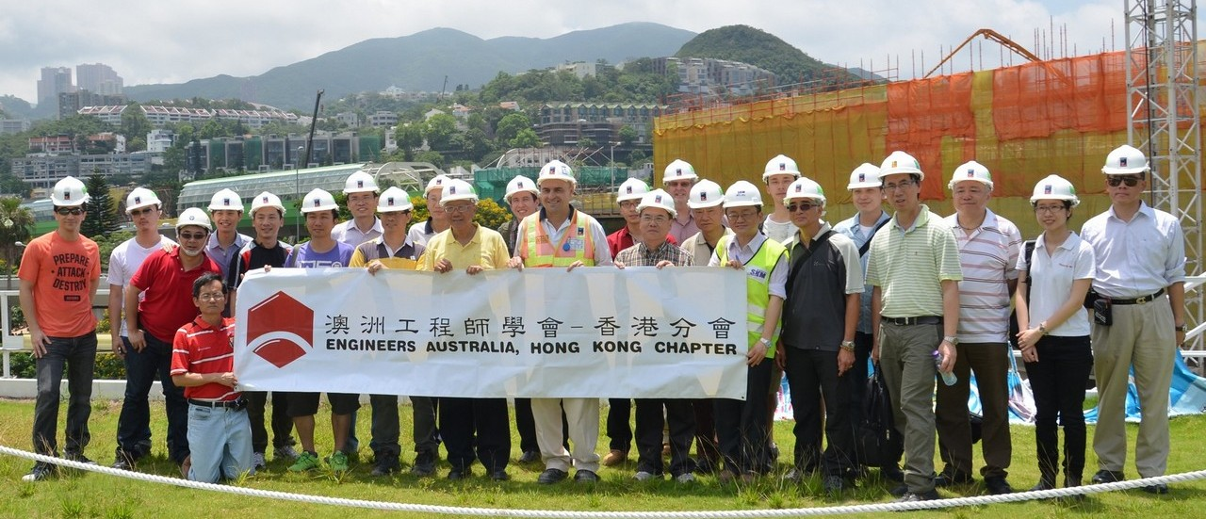


Visit to South Island Line (East) Rail Project

Date, Time & Place
Date: (Saturday) 29 June 2013 from 9:00 am to 12:00am
Meeting Place : Bus Pickup at Kent Road, Kowloon Tong MTR (Limited to 25 Places)

Background Information
The project involves the construction of two elevated stations at Ocean Park and Wong Chuk Hang, 2.1km of viaduct that forms the above-ground section of the railway and a 246m-long bridge over the Aberdeen Channel.

The new station at Ocean Park connects to the entry plaza of the marine theme park via an elevated walkway, while the station at Wong Chuk Hang is being built with a public transport interchange underneath.

The viaduct has three sections, with the first crossing several busy roads coming out of Aberdeen Tunnel. The other two sections are being constructed in or around a drainage nullah, where there are restricted working conditions due to limited space and reduced access during the rainy season. The main bridge has a 115m-long balanced cantilever span over the Aberdeen Channel

Following the site visit, participants will be taken back to the Engineer’s offices to drop off PPE and from there back to the Kowloon Tong drop-off point.
[PLEASE NOTE – PARTICIPANTS MUST BRING THEIR OWN PROTECTIVE FOOTWEAR, COMPRISING STEEL-TOED CONSTRUCTION BOOTS. REFLECTIVE VESTS AND CONSTRUCTION HARD HATS WILL BE PROVIDED ON SITE.]

Continuing Professional Development (CPD)
Attending Engineers Australia members will be issued with a certificate acknowledging 3 hours of CPD.

Notice for Registration
- Due to limited places, priority will be given to members.
- All participants should be responsible for their own saftey and belongings and need to sign an Undertaking upon registration.
- If typhoon ssiganl no. 3 (or above) or the rainstorm warning (red or black) is hoisted or announced to be hoisted in effect within two hours prior to the start of the visit, the visit will be cancelled without further notice.
- Please complete and return the attached Forms to Simon FAN by email: info@ieausthk.org
or FAX: 2430 9080.
- Successfull applicants will only be confirmed by Simon FAN (phone : 9351 4963)

Engineers Australia Hong Kong Chapter: Technical Visit
“Visit to South Island Line (East) Rail Project”
(29 June 2013) Registration Form

To: Simon FAN
From:

Name in full: |  |  | IEAust no.
Mobile : |  |  | Email:

Form of Undertaking

I fully understand and willingly accept that any invitation or permission gives to me to visit the South Island Line (East) Project shall be subject to but not exclusive to the following conditions:-

- Engineers Australia, Hong Kong Chapter (EAHK) and/or the organizer(s) shall owe no common duty of care to any visitor in respect of risks or dangers arising from the state of the facilities, or execution of any work or the carrying out of any activities therein.

- EAHK and/or the organizer(s) shall be absolved from all liabilities arising out of any incident or accidents causing loss, damage or personal injury (whether fatal or otherwise) howsoever caused to the visitior and whether the same is caused by negligence or not.

I am also fully aware that the signing of this Form of Undertaking by me shall indicate my acceptance of any risk or danger encountered due to the visit dated 29 June 2013.

Signature : ____________

Full Name: ______________

Date :

