
Zero Carbon Building Visit

Date, Time & Place
Date: (Monday) 11 March 2013 from 4:00PM to 6:00PM
Place : 8 Sheung Yuet Road, Kowloon Bay, Kowloon

Background InformationIn order to combat the increasing pressure from climate change, the Hong Kong Government has proposed targets for greenhouse gas (GHG) emissions reduction. Buildings are the major contributor to GHG emissions in Hong Kong and are therefore both a challenge as well as an opportunity for GHG emissions reduction. As such, the construction industry has a significant role to play in GHG emissions reduction. Within the ambit of the Construction Industry Council Ordinance, one of the functions of Construction Industry Council (CIC) is to promote good practices in the construction industry in relation to environmental protection, sustainable construction and other areas conducive to improving construction quality. On this basis, CIC, in collaboration with the Hong Kong Government, is developing the first Zero Carbon Building in Hong Kong. Now, you have to the chance to visit the ZCB free of charge.
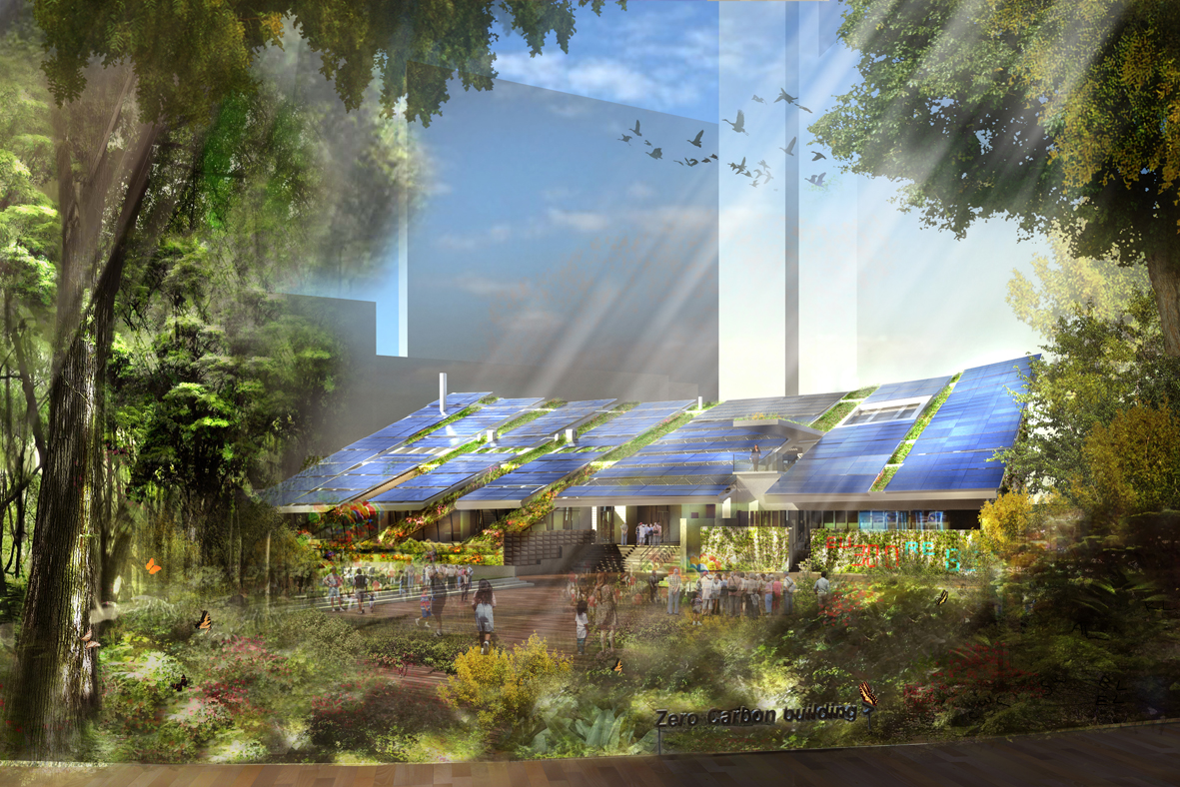

Continuing Professional Development (CPD)
Attending Engineers Australia members will be issued with a certificate acknowledging 2 hours of CPD.

Notice for Registration
- Due to limited places, priority will be given to members.
- All participants should be responsible for their own saftey and belongings.
- Bad weather arrangment is subject to the rules governed by the ZCB authority.
- Please complete and return this form to Simon FAN by email: info@ieausthk.org or FAX: 2430 9080.
- Successfully applicants will only be confirmed by Simon FAN (phone : 9351 4963)

Engineers Australia Hong Kong Chapter: Technical Visit
“Visit to Zero Carbon Building”
(11 March 2013) Registration Form

To: Simon FAN
From:

Name in full: |  |  | IEAust no.
Mobile : |  |  | Email:

