
Technical Visit to Sludge Incinerator

Date, Time & Place
Date: 14 December 2013 (Saturday) from 8:30 am to 12:00am
Meeting Place : Bus Pickup at Tsuen Wan MTR (details to be provided to successful applicants).

Background Information
The Hong Kong Sludge Incinerator is being built for the Hong Kong Government under the direction of the Environmental Protection Department, pursuant to a Design, Build and Operate Contract by an EPC Joint Venture Contractor. The project has substantially completed the civil engineering and building phase and is now entering the testing and commissioning phase. As such, this visit will be of great interest to Mechanical and Electrical Engineers, as well as Civil Engineers, and to all engineers interested in improving Hong Kong’s environment. The key features of the project are as follows:
- World’s Largest Sludge Incineration Facility;
- Meets most stringent European Air Quality;
- Capable of generating 28MW of electricity;
- Zero discharge to Deep Bay;
- Environmental Education Centre; and,
- Outstanding Architecture and landscaping as shown by the image of the completed structure below:
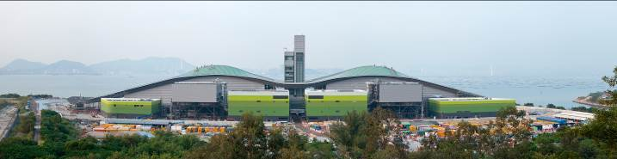

At the commencement of the site visit there will be a project briefing and a site safety induction. Following the site tour, participants will be taken back to the project offices to drop off PPE and pick up personal belongings.
[PLEASE NOTE – PARTICIPANTS MUST BRING THEIR OWN PROTECTIVE FOOTWEAR. Reflective vests and hard hats will be provided on site – although participants may bring their own if desired.

Continuing Professional Development (CPD)
Attending Engineers Australia members will be issued with a certificate acknowledging 3 hours of CPD.
Notice for Registration
- The number of visitors is limited to 35, and priority will be given to EAHK members.
- All participants should be responsible for their own safety and belongings and need to sign an Undertaking upon registration.
- If typhoon signal no. 3 (or above) or the rainstorm warning (red or black) is hoisted or announced to be hoisted in effect within two hours prior to the start of the visit, the visit will be cancelled without further notice.
- Please complete and return the attached Forms to Simon FAN by email: info@ieausthk.org
or FAX: 2430 9080.
- Successfull applicants will only be confirmed by email from Simon FAN (phone : 9351 4963)

Engineers Australia Hong Kong Chapter: Technical Visit
“Visit to Sludge Incinerator”
(14 December 2013) Registration Form

To: Simon FAN
From:

Name in full: |  |  | IEAust no.
Mobile : |  |  | Email:

Form of Undertaking

I fully understand and willingly accept that any invitation or permission gives to me to visit the Sludge Incinerator Project shall be subject to but not exclusive to the following conditions:-

- Engineers Australia, Hong Kong Chapter (EAHK) and/or the organizer(s) shall owe no common duty of care to any visitor in respect of risks or dangers arising from the state of the facilities, or execution of any work or the carrying out of any activities therein.

- EAHK and/or the organizer(s) shall be absolved from all liabilities arising out of any incident or accidents causing loss, damage or personal injury (whether fatal or otherwise) howsoever caused to the visitor and whether the same is caused by negligence or not.

I am also fully aware that the signing of this Form of Undertaking by me shall indicate my acceptance of any risk or danger encountered due to the visit dated 14 December 2013.

Signature :

Full Name:

Date:

