Visit of Lamma Power Station by Elsworth Leung
On 5 October 2013 morning, 20 members of EAHK gathered at South Horizons at Ap Lei Chau to board the Hong Kong Electric ferry to Lamma Power Station. This technical visit was organized by Mr. Elsworth Leung. He first gave a detailed summary about the Lamma Power station, describing the power production, the need for environmental control and the value of protection to the environment. With this commitment in mind Hong Kong Electric has installed various kinds of equipment in the Lamma Power Station to protect the surrounding nature.
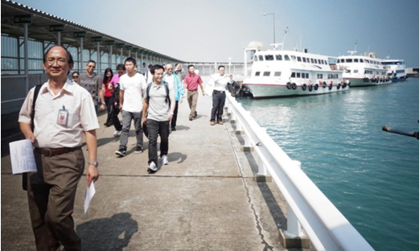
Upon arrival at Lamma Island, the party went directly to the Exhibition Centre to have an overview of the Power Station. There were various exhibits which included models such as the layout of the power station, the distribution of electricity across Hong Kong Island and Lamma Island, as well as the working of machinery to generate electricity. The Lamma Power Station has been in operation since 1982 with a total power generating capacity of 3,736MW.
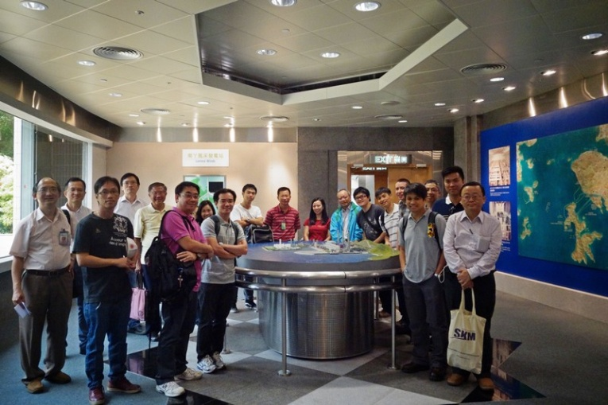
Presently about 70% of electricity generation is by burning coal, and the power station has implemented a wide range of measures in environmental protection, for instance, electrostatic precipitators, Flue Gas Desulphurization, low nitrogen oxides Burners and three tall chimneys over 210 meters height each. In addition, the power station also installed Natural Gas Fired Combined Cycle Plants, generating electricity with higher efficiency but less pollutant emission of sulphur oxides and particulates. Further with the installation of Wind Turbine and Solar Panels, the power station supports the idea to generate sustainable electricity using renewable energy, thus minimizing Green House Gas emissions and promoting a low carbon economy in Hong Kong.
Leaving the Visitor Exhibition Centre, the visitors passed by two huge structures called Flue Gas Desulphurization Plant for Generating Units 6 & 7. For each unit, there was a tall tower with many big and small piping and ducting in and out of the tower where transfer of flue gas, limestone and gypsum slurry took place. The function of this tower is to remove the sulphur oxides from the flue gas by limestone absorption process. The by-product is gypsum, which is then dispatched for the production of building material. The gypsum was stored in a mushroom-like structure known as the gypsum dewatering plant, from which the gypsum was delivered to a pier and disposed into barges to deliver to landfill site. Along the road, there were furnaces of the generating units which were constructed with multi-steel beams and pipe-work.
After passing over a bridge, the group arrived at an extended island on which a number of environmental initiatives were developed. A solar photovoltaic system and micro wind-turbines were installed to provide energy for street lighting as well as other electric powered facilities. Shortly after, the visitors reached a large open area with hundreds of Thin Film Photovoltaic modules each rated at 100W peak output. The view was absolutely marvelous which almost seem like everyone was floating on top of a sea of mirrors, and all our members were busy taking photographs there. Mr. Leung stated that the whole solar power system currently comprises of 8,662 photovoltaic modules, which are installed on the roof tops of buildings and various open locations of the Lamma Power Station adding up to a total output capacity of 1 MW.
Opposite to the solar panel field was where the Gas Fired Combined Cycle plant was located. The participants visited the turbine hall where it contained a generator, a steam turbine and a gas turbine all coupled in a single shaft. This hall was designed to adhere to the green requirement using translucent cladding to introduce natural light. Thus the light inside the hall was quite gentle to vision but the heat flux in the hall was high enough to make each visitor sweating inside and out!
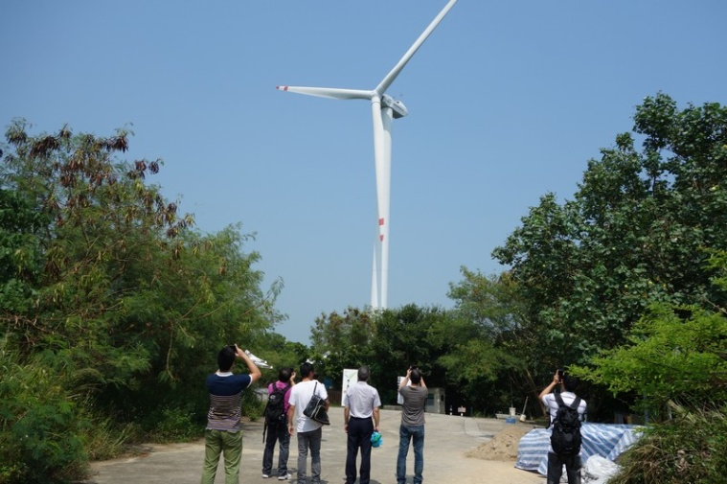
Leaving the Power Station compound the party walked up a steep road to visit the Lamma Wind Station. The station perched atop of Tai Ling on the northern part of Lamma Island. It housed the wind turbine, which has a rated capacity of 800KW. Although this is just a small wind turbine, our members were able to feel the majestic aesthetics and grandeur essence of the green energy machine. The diameter of the turbine blade is 50m and the wind turbine itself stands at 75m high above ground. Unfortunately the wind turbine was on a routine maintenance check during the tour, but interesting information about wind, solar and other common forms of renewable energy and examples of their applications worldwide could be found in the exhibition panels of the Lamma Wind Station.
This visit provided our members a rare opportunity to see the various power generation facilities and the environmental protection measures, together with the renewable energy generation in the Lamma Power Station. Our Chairman Mr. William Chan then thanked Mr. Leung and the Hong Kong Electric staff who guided the tour group. The visit ended in the Lamma Wind Station, but the activity was not finished yet.
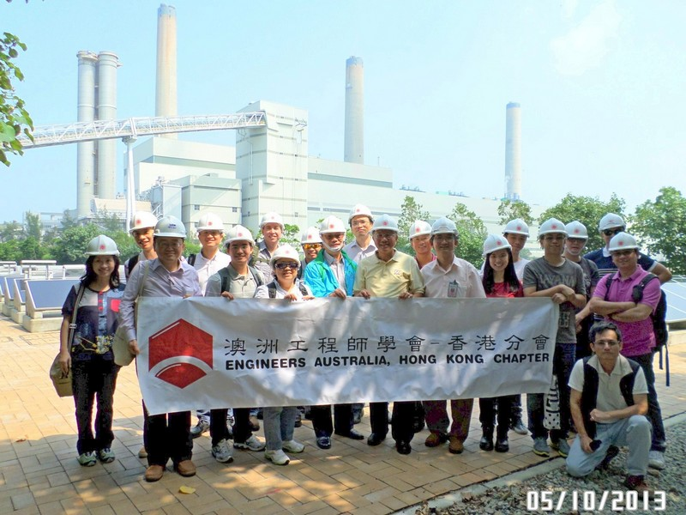
Some participants continued hiking around this beautiful island, others enjoyed an excellent meal of fresh seafood at Yung Shue Wan before leaving the island by public ferry back to Hong Kong.
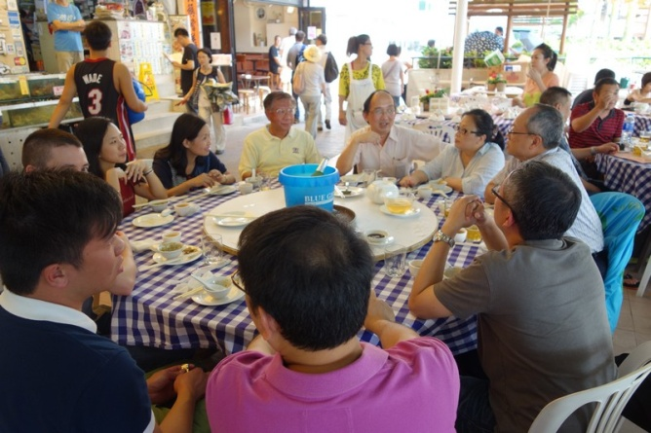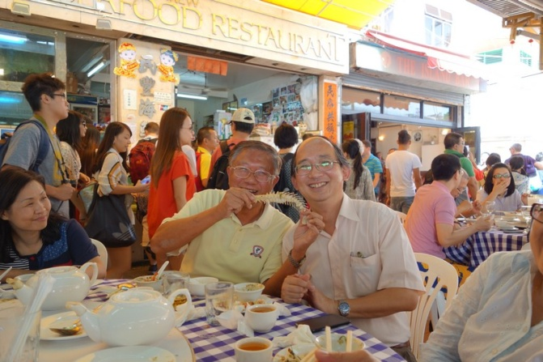
Additional photos available at:
https://www.facebook.com/media/set/?set=a.525732874180498.1073741846.346241825462938&type=3


Techncial Visit to Lamma Power Station
Lamma Island

Date, Time & Place
Date: 5 October 2013 (Saturday) from 10:00 am to 13:00pm
Meeting Place : The Hongkong Electric Co. Ltd., CarPark Buidling, South Horizons, Ap Lei Chau.
(Gathering time: 09:30 am and 09:45 am leaving for security registration for boarding)

Background Information
Lamma Power Station is the power generation station supplying electricity to Hong Kong and Lamma Island. The first 250MW unit was commissioned in 1982, and now the station has a total installed unit capacity of 3,736.8 MW. In order to cope with the requirements of environmental control and produce green electricity, the Power Station has installed variety of facilities such as Flue Gas Desulphurisation units, Dry Low Nox burners, high efficient gas firing Combined Cycle units, Wind Turbine and Thin Flim Photovoltaic Solar Power System etc. to reduce harmful emissions. You will have the opportunity to see green power generating equipment in the Power Station.
.
At the conclusion of the site visit to the Wind Turbine, participants will be dismissed at Yung Shue Wan and can take the 13:00 ferry back to Hong Kong (Central) or continue touring around Lamma Island at their own choice. The ferry time table has been attached for your reference. In addition, members are welcome for lunch at their own costs.

[PLEASE NOTE – PARTICIPANTS MUST BRING THEIR OWN PROTECTIVE FOOTWEAR. HARD HATS WILL BE PROVIDED ON SITE – however, you can bring your own set of PPE if you wish]

Continuing Professional Development (CPD)
Attending Engineers Australia members will be issued with a certificate acknowledging 3 hours of CPD.

Notice for Registration
- The number of visitors is limited to 30, and priority will be given to EAHK members.
- All participants should be responsible for their own saftey and belongings and need to sign an Undertaking upon registration.
- If typhoon signal no. 1 (or above) or the rainstorm warning (red or black) is hoisted or announced to be hoisted in effect within two hours prior to the start of the visit, the visit will be cancelled without further notice.
- Please complete and return the attached Forms to Simon FAN by email: info@ieausthk.org
or FAX: 2430 9080 on or before 25th Sept 2013.
- Successfull applicants will only be confirmed by Simon FAN (phone : 9351 4963)

Engineers Australia Hong Kong Chapter: Technical Visit
“Visit to Lamma Power Station”
(Saturday, 5th October 2013) Registration Form
To: Simon FAN
From:
Name in full: |  |  | IEAust no.
Mobile : |  |  | Email:
Gender: | □ Mail □ Female |  | Lunch | □ Yes □ No

Form of Undertaking
I fully understand and willingly accept that any invitation or permission gives to me to visit the Lamma Power Station shall be subject to but not exclusive to the following conditions:-
- Engineers Australia, Hong Kong Chapter (EAHK) and/or the organizer(s) shall owe no common duty of care to any visitor in respect of risks or dangers arising from the state of the facilities, or execution of any work or the carrying out of any activities therein.
- EAHK and/or the organizer(s) shall be absolved from all liabilities arising out of any incident or accidents causing loss, damage or personal injury (whether fatal or otherwise) howsoever caused to the visitor and whether the same is caused by negligence or not.

I am also fully aware that the signing of this Form of Undertaking by me shall indicate my acceptance of any risk or danger encountered due to the visit dated 5th October 2013.
Signature :
Full Name:
Date :
Visit of Lamma Power Station:
Gathering Location: South Horizons, ApLei Chau, Hong Kong
Gathering Time: 09:30 am, 5th Oct., 2013.
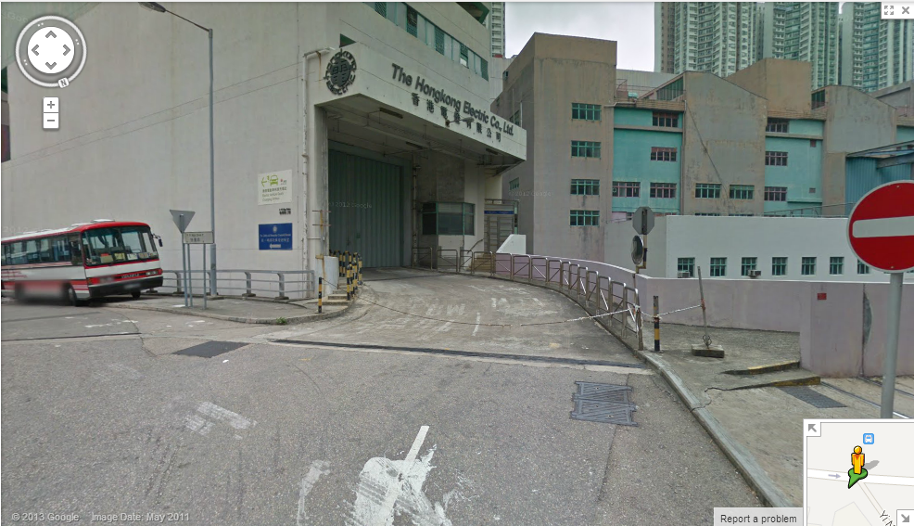
Gathering point
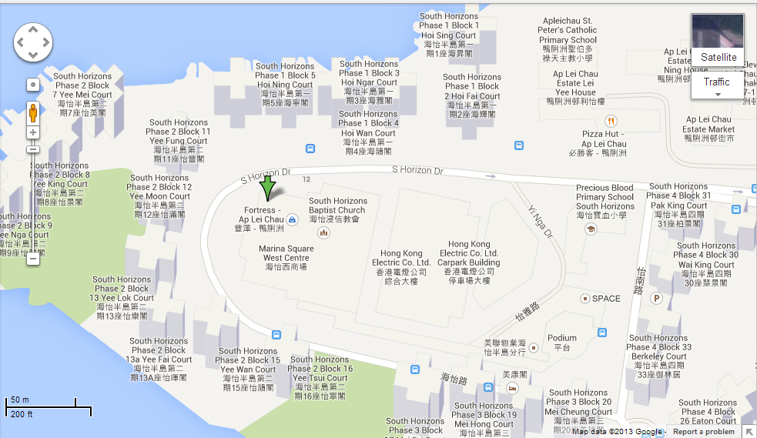
Gathering point
