Seminar on Alternative Trenchless Method
by Hand Shield Tunnelling

by Simon Tong

The captioned seminar was successfully held on 15 August 2013. There were two speakers from Bestwin Engineering Ltd: Mr. Albert Tsui (Executive Director) and
Mr. Danny Yung (director), both of them are specialized in underground tunneling works. A total of 64 members attended this seminar.

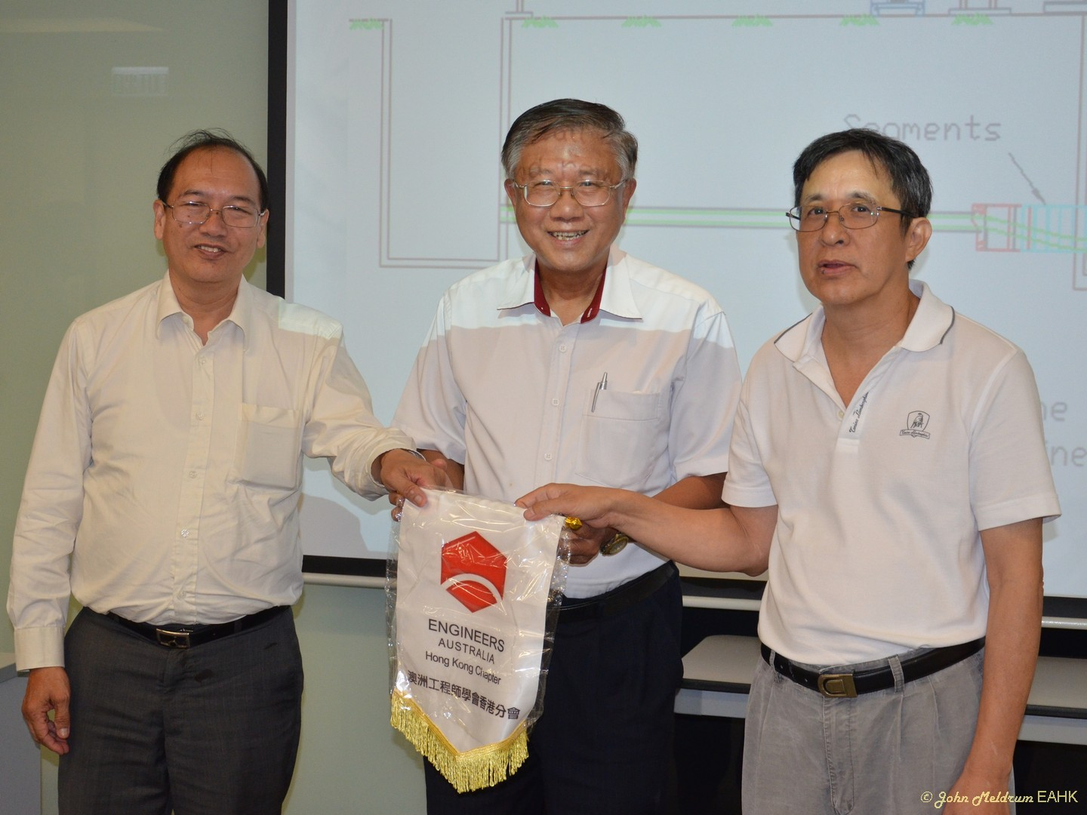

Mr. Tsui started with an introduction to underground tunneling methods commonly used in Hong Kong. They include tunnel boring machines (TBM) for large diameter
tunnels; horizontal directional drill（HDD）for medium diameter tunnels，as well as pipe jacking method and hand-digging method for small diameter tunnels. The latter may be further subdivided into heading method and hand shield method -- also called segmental pipe jacking method as further discussed in the following paragraphs. This method may be adopted for tunnels between 1.2m to 3.0m diameter，but for practical purposes the preferred minimum diameter is 1.6m. It has a long history dated back to 1825 in London U.K..

Mr. Yung went on to discuss the tunneling method. First of all，a jacking pit and a receiving pit are formed. Following completion of the jacking pit, a 1.8m long steel open shield head, made up of 2 pieces, is lowered into the pit. Excavation of the first 500mm

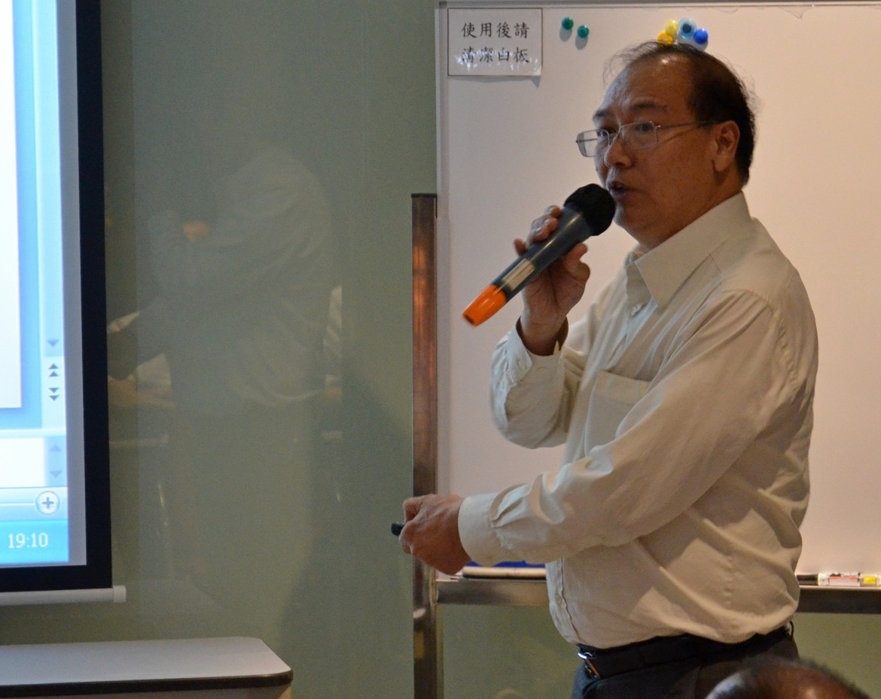
can then commence. The shield head is then jacked forward，and digging of the next 500mm followed and the shield head jacked forward. For subsequent drives, when excavation reaches about 400mm, a 3-piece steel segment ring is installed using bolt and nut jointing to support the tunnel face, which will be left in-situ. The excavation process is repeated until it reaches the receiving pit, where the shield head will be retrieved. The alignment and level is controlled by laser target blocks. In locations where groundwater table is high and depending on the existing ground condition, it is necessary to carry out advanced grouting 4m to 6m ahead of the shield head. It is also recommended to have a minimum cover of 1.5 times the tunnel diameter under traffic.

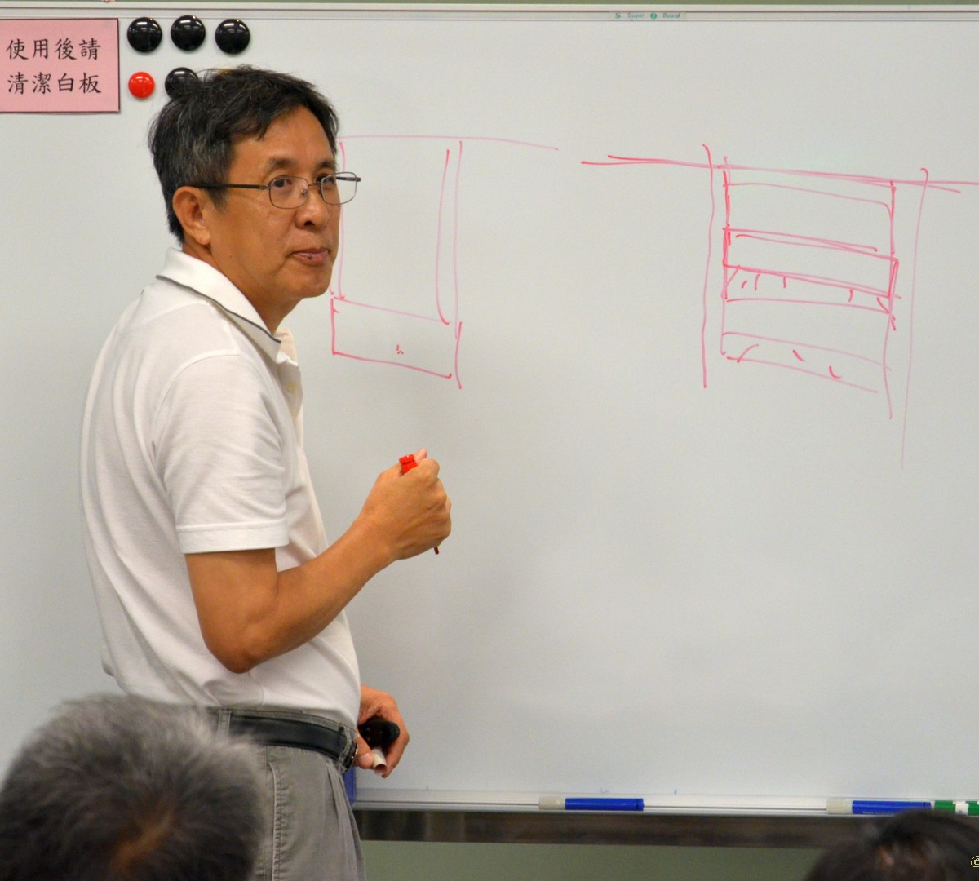
Mr. Yung then discussed the advantages of hand shield method compared with the pipe jacking method. For the former, no thrust wall is required since only small jacks (4 nos. 30 tonnes each) are used. The jacking pit can be very small and 1.2m to 1.5m diameter is sufficient, whereas the pit for pipe jacking ranges from 3 to 4m. This is very important in urban areas with congested utilities and busy traffic. The method is most suitable for tunneling at locations where there are traffic restrictions, for example, limited temporary traffic arrangement period from 10 a.m. to 4 p.m. daily and so it is not possible to carry out sheet piling work for constructing the pits. He cited that in such case an existing manhole may be modified to form the jacking pit. He went on to discuss the application of the hand shield method in special situations. In one case this method was used to "save" a stuck cutter head used for pipe jacking under the airport runway. In another case it was used to install a new drainage pipe from an existing manhole while maintaining flow in the pipeline to be abandoned.

Finally, Mr. Yung stressed that safety is the most important consideration in hand shield tunneling, which is classified as working in confined space. It is necessary to carry out a detailed risk assessment prior to any excavation work. The potential dangers include collapse of soil, flooding due to inflow of ground water, presence of poisonous gases, harms when working in high temperature and humid environment, and interruption of fresh air supply. The excavation work shall follow the approved method statement, which together with the Temporary Works design must be endorsed by an Independent Checking Engineer. Above all, the hand-digging tunneling works should only be carried out by skilled and experienced workers under the supervision of competent foremen.

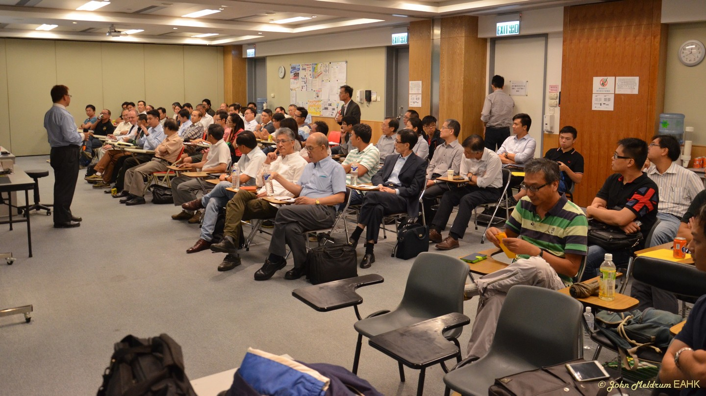

An interactive question and answer session was held immediately after the presentation. A member asked about the possible ground settlement during the hand shield tunneling, and another member questioned the segmental lining method for constructing the pits. These were adequately responded by the speakers. This presentation provided participants with a good opportunity to understand this type of trenchless tunneling method, its advantages and the special applications. On behalf of EAHK, we would like to express our sincere appreciation to both speakers for their generous sharing of experience, and to the participants for their support.

Additional photos of the evening are available at:
https://www.facebook.com/media/set/?set=a.496471733773279.1073741842.346241825462938&type=3

Photos by: John Meldrum


Hand Shield Tunneling- Alternative Trenchless Method
Date, Time & Venue
15 August 2013 (Thursday): 6:00pm (Networking), 7:00pm (Start of Seminar)
Hong Yip Training Centre at 5/F, New East Sun Industrial Bldg., No. 18 Shing Yip Street, Kwun Tong, Kowloon

Programme Highlights

Hand shield tunnelling is one of the alternative methods to undertake underground piping works. This is widely adopted in roads with congested utilities, in road junctions / roundabouts where pipe laying work using open trench method is difficult. It requires skillful labours with good working team , and the team members must be in close communication in and out of the tunnel. Strict rules are applied to confined space activities and in accordance with the current ordinances and regulations.

Safety concerns as well as works approach are important issues in hand shield tunnelling . Works within the sand, clay and hard rock underground condition have different schedules and procedures. Serious traffic impact above ground is always critical due to possible settlement along the alignment of tunnelling. All these issues will be discussed.

Speakers:
Mr. Albert Tsui, Executive Director of Bestwin Engineering Ltd. having more than 30 years experience in civil engineering and is specialised in underground works;
Mr. Danny Yung, Director of Bestwin Engineering Ltd. Is specialised in undetrground tunnellling works such as TBM, hand shield tunnelling etc.

Special Highlights
- Open hand shield pipe jacking method
- Hand dig tunnel shield method (segmental circular type lining & segmental horseshoe type lining)
- Segmental vertical shaft

Light refreshment will be served during the event to Engineers Australia members .

Continuing Professional Development (CPD)
Attending Engineers Australia member will be issued with a certificate acknowledging 1.5 hours of CPD.

Registration & Enquiries

The Technical Talk is free of charge. Please complete and return this form to Simon FAN by email: info@ieausthk.org or FAX: 2430 9080 by 14 August 2013. For enquiries, please contact Simon FAN on 9351 4963.

Engineers Australia Hong Kong Chapter: Technical Talk
“Hand Shield Tunnelling- Alternative Trenchless Method”
15 August 2013: 6:00pm to 8:00pm
Registration Form

To: Simon FAN
From:

Name in full: |  |  | IEAust no.
Mobile : |  |  | Email:

