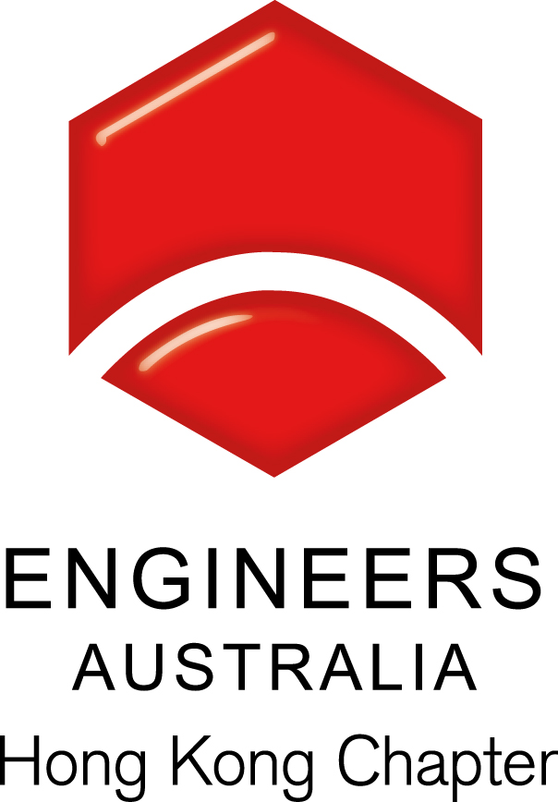
Technical Talk: EA-HKIE Membership
Date, Time & Venue
21 September 2012 (Friday): 6:00pm (Networking), 6:30pm (Start of Seminar)
The Australian Consulate General, Hong Kong, “The Wombat Hole” 24/F Harbour Centre,
25 Harbour Road, Wanchai, Hong Kong

Programme Highlights
The talk is designed to introduce the following:
- The Hong Kong Institution of Engineers (HKIE) and the values of its membership;
- Routes to membership: The Reciprocal Recognition Agreement (RRA) between HKIE and Engineers Australia (EA);
- Application procedures via RRA between HKIE and EA.

Speaker: Mr. Albert Chow
Mr Albert CHOW is currently the Director of Qualifications of the Hong Kong Institution of Engineers. Concurrently, he is also the Registrar of the Engineers Registration Board established under the Engineers Registration Ordinance. Mr CHOW has extensive experience in accreditation, training, continuing professional development and international recognition. He was responsible for developing accreditation systems for engineering degrees, computer science degrees and higher diplomas in Hong Kong leading to international recognition under the Washington Accord, the Sydney Accord and the Seoul Accord. He was also responsible for establishing 16 Reciprocal Recognition Agreements with authorities all over the world, including two agreements on mutual recognition on Information Technology qualifications. He is currently a Member of the Hong Kong Institution of Directors, a Fellow of the Institute of Administrative Management (UK) and a Member of the Chartered Management Institute (UK). He was a Founding Member, Treasurer, Executive and Council Member of the Chartered Management Institute (Hong Kong Branch).

Special Highlights
Two free soft drinks or beers will be served during the event to the Engineers Australia members who are present at the technical talk.

Continuing Professional Development (CPD)
Attending Engineers Australia members will be issued with a certificate acknowledging 1.5 hours of CPD.

Remarks, Registration & Enquiries
If typhoon signal no. 3 (or above) or the rainstorm warning (red or black) is hoisted or announced to be hoisted in effect within two hours prior to the start of the talk, the talk will be cancelled without further notice.
The seminar is free of charge. Please complete and return this form to Simon FAN by email: info@ieausthk.org or FAX: 2430 9080 by 19 September 2012. For enquiries, please contact Simon FAN on 9351 4963.

Engineers Australia Hong Kong Chapter: Technical Talk
EA-HKIE Membersip
21 September 2012: 6:00pm to 8:00pm
Registration Form

To: Simon FAN
From:

Name in full: |  |  | IEAust no.
Mobile : |  |  | Email:

