
Technical Talk: Offshore Wind Farm – Met Mast Experience
Date, Time & Venue
19 October 2012 (Friday): 6:00pm (Networking), 7:00pm (Start of Seminar)
The Australian Consulate General, Hong Kong, “The Wombat Hole” 24/F Harbour Centre,
25 Harbour Road, Wanchai, Hong Kong

Programme Highlights

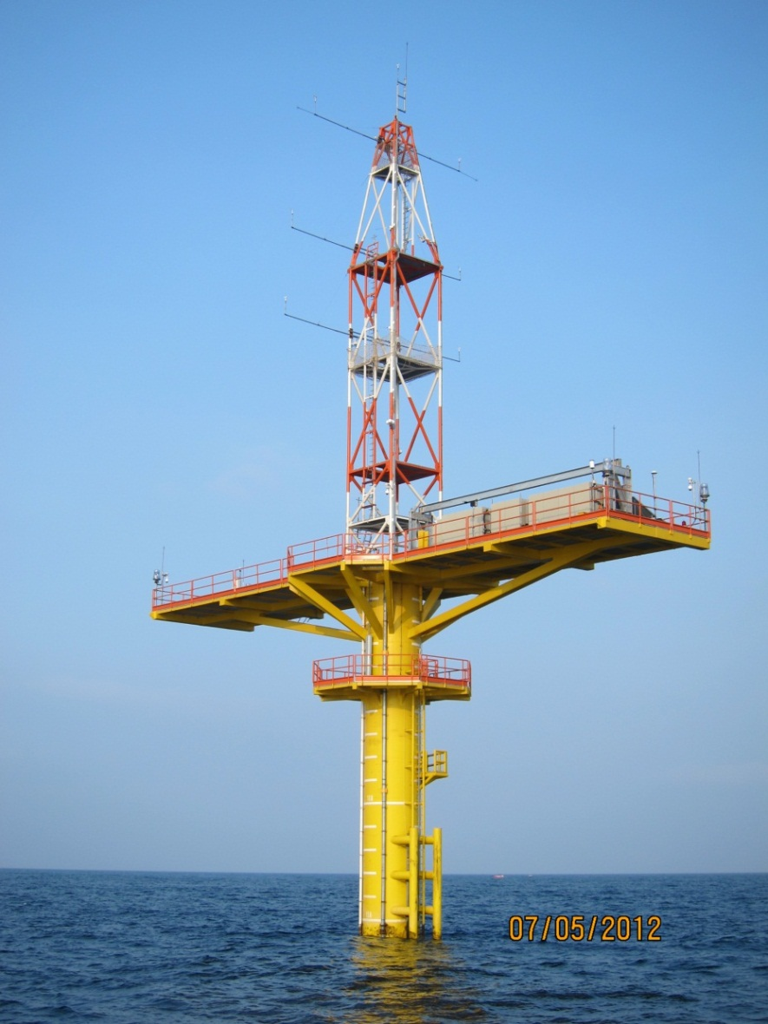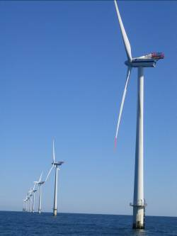
CLP Offshore Met Mast Typical Offshore Wind Farm
CLP Power Hong Kong Ltd is currently conducting a feasibility study of constructing an up to 200MW Offshore Wind Farm in the South Eastern Waters of Hong Kong.
The feasibility study involves the installation of a meteorological monitoring mast (met mast) for gathering of environmental data over a period of at least 12 months. Offshore Suction Caisson Foundation Technology was selected to be used due to its environmental and economic benefits. The installation method of pumping out water from within the caisson to generate net differential water pressure which drives the pile into soil has the benefits of minimal noise impact, no requirement for dredging, quick installation, minimum disturbance to seabed, ease of decommissioning and “re-usability” at other location, etc. At the end of the wind farm’s operation life, the suction installed foundations could be removed completely from the seabed, unlike piled foundations. The fabrication and installation of the meteorological mast structure were designed to be similar to those of the foundation of the offshore wind farm. It took about 6 months to complete the onshore fabrication but the installation offshore was completed within 4 days; installation was completed on 6 April 2012.
The talk will cover our experience of the met mast fabrication and installation especially on the use of “Suction Caisson” foundation. In addition, we will explain how the met mast will be utilized and will give an overview of how energy production assessment will be conducted by using the environmental data collected.

Speaker: Ir Ada CHAN
Ir. Ada Chan is CLP’s Engineering Manager for the offshore wind farm feasibility study. She received her Bachelor degree and Master Degree in Civil Engineering and Structural Engineering at University of Toronto, Canada, and received her MBA at Hong Kong University of Science and Technology. She is a member of the HKIE and Institution of Structural Engineers UK.

Special Highlights
Two free soft drinks or beers will be served during the event to the Engineers Australia members who
are present at the technical talk.

Continuing Professional Development (CPD)
Attending Engineers Australia members will be issued with a certificate acknowledging 1.5 hours of CPD.

Remarks, Registration & Enquiry
- If typhoon signal no.8 (or above) or the rainstorm warning (red or black) is hoisted or announced to be hoisted in effect within two hours prior to the start of the talk, the talk will be cancelled without further notice.
- Engineers Australia Hong Kong Chapter or the organizer willn ot accept any liability in conncection with this function. All participants should be responsible for their own safety and belongings. The organizer(s) shall not held responsible for any losses or accidents arising from or in connecton with this function.
- The seminar is free of charge. Please complete and return this form to Simon FAN by email: info@ieausthk.org or FAX: 2430 9080 by Tuesday 16 October 2012. For enquiry, please contact Simon FAN on 9351 4963.

Engineers Australia Hong Kong Chapter: Technical Talk
Offshore Wind Farm – Met Mast Experience
19 October 2012: 6:30pm to 8:00pm
Registration Form

To: Simon FAN
From:

Name in full: |  |  | IEAust no.
Mobile : |  |  | Email:

