
ENGINEERS AUSTRALIA, HONG KONG CHAPTER
Visit the Elders
Santa Claus Coming to Town (暖意歡騰迎聖誕)
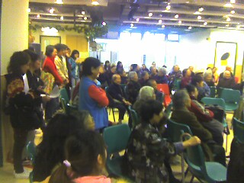
Date and Location:-
9 December, 2012 (9:00-13:00)
Aberdeen Kai-fong Welfare Association Social Service,
Address: Hall, 1/F, 180B Aberdeen Main Road, Aberdeen.

Objective:
To send out warm visit and tangible gifts to community elders and caregivers through conducting home visits by volunteers from Engineers Australia, HK Chapter.
Target Clientele and Outputs:
We shall deliver gifts to elder people (about 800) for their celebration of winter solstice (冬至)

For registration, please complete and return the underneath form by email:info@ieausthk.org or FAX 2430 9080 before 1 December 2012.
For enquiry, please call Simon FAN on 9351 4963

Visit the Elders (9 December2012) Registration Form
TO: Mr. Simon FAN

From : ______________ IEAust No.

Phone No._______________ email ___________________

*A van will be arranged by EAHK to pick up participants for this visit.

